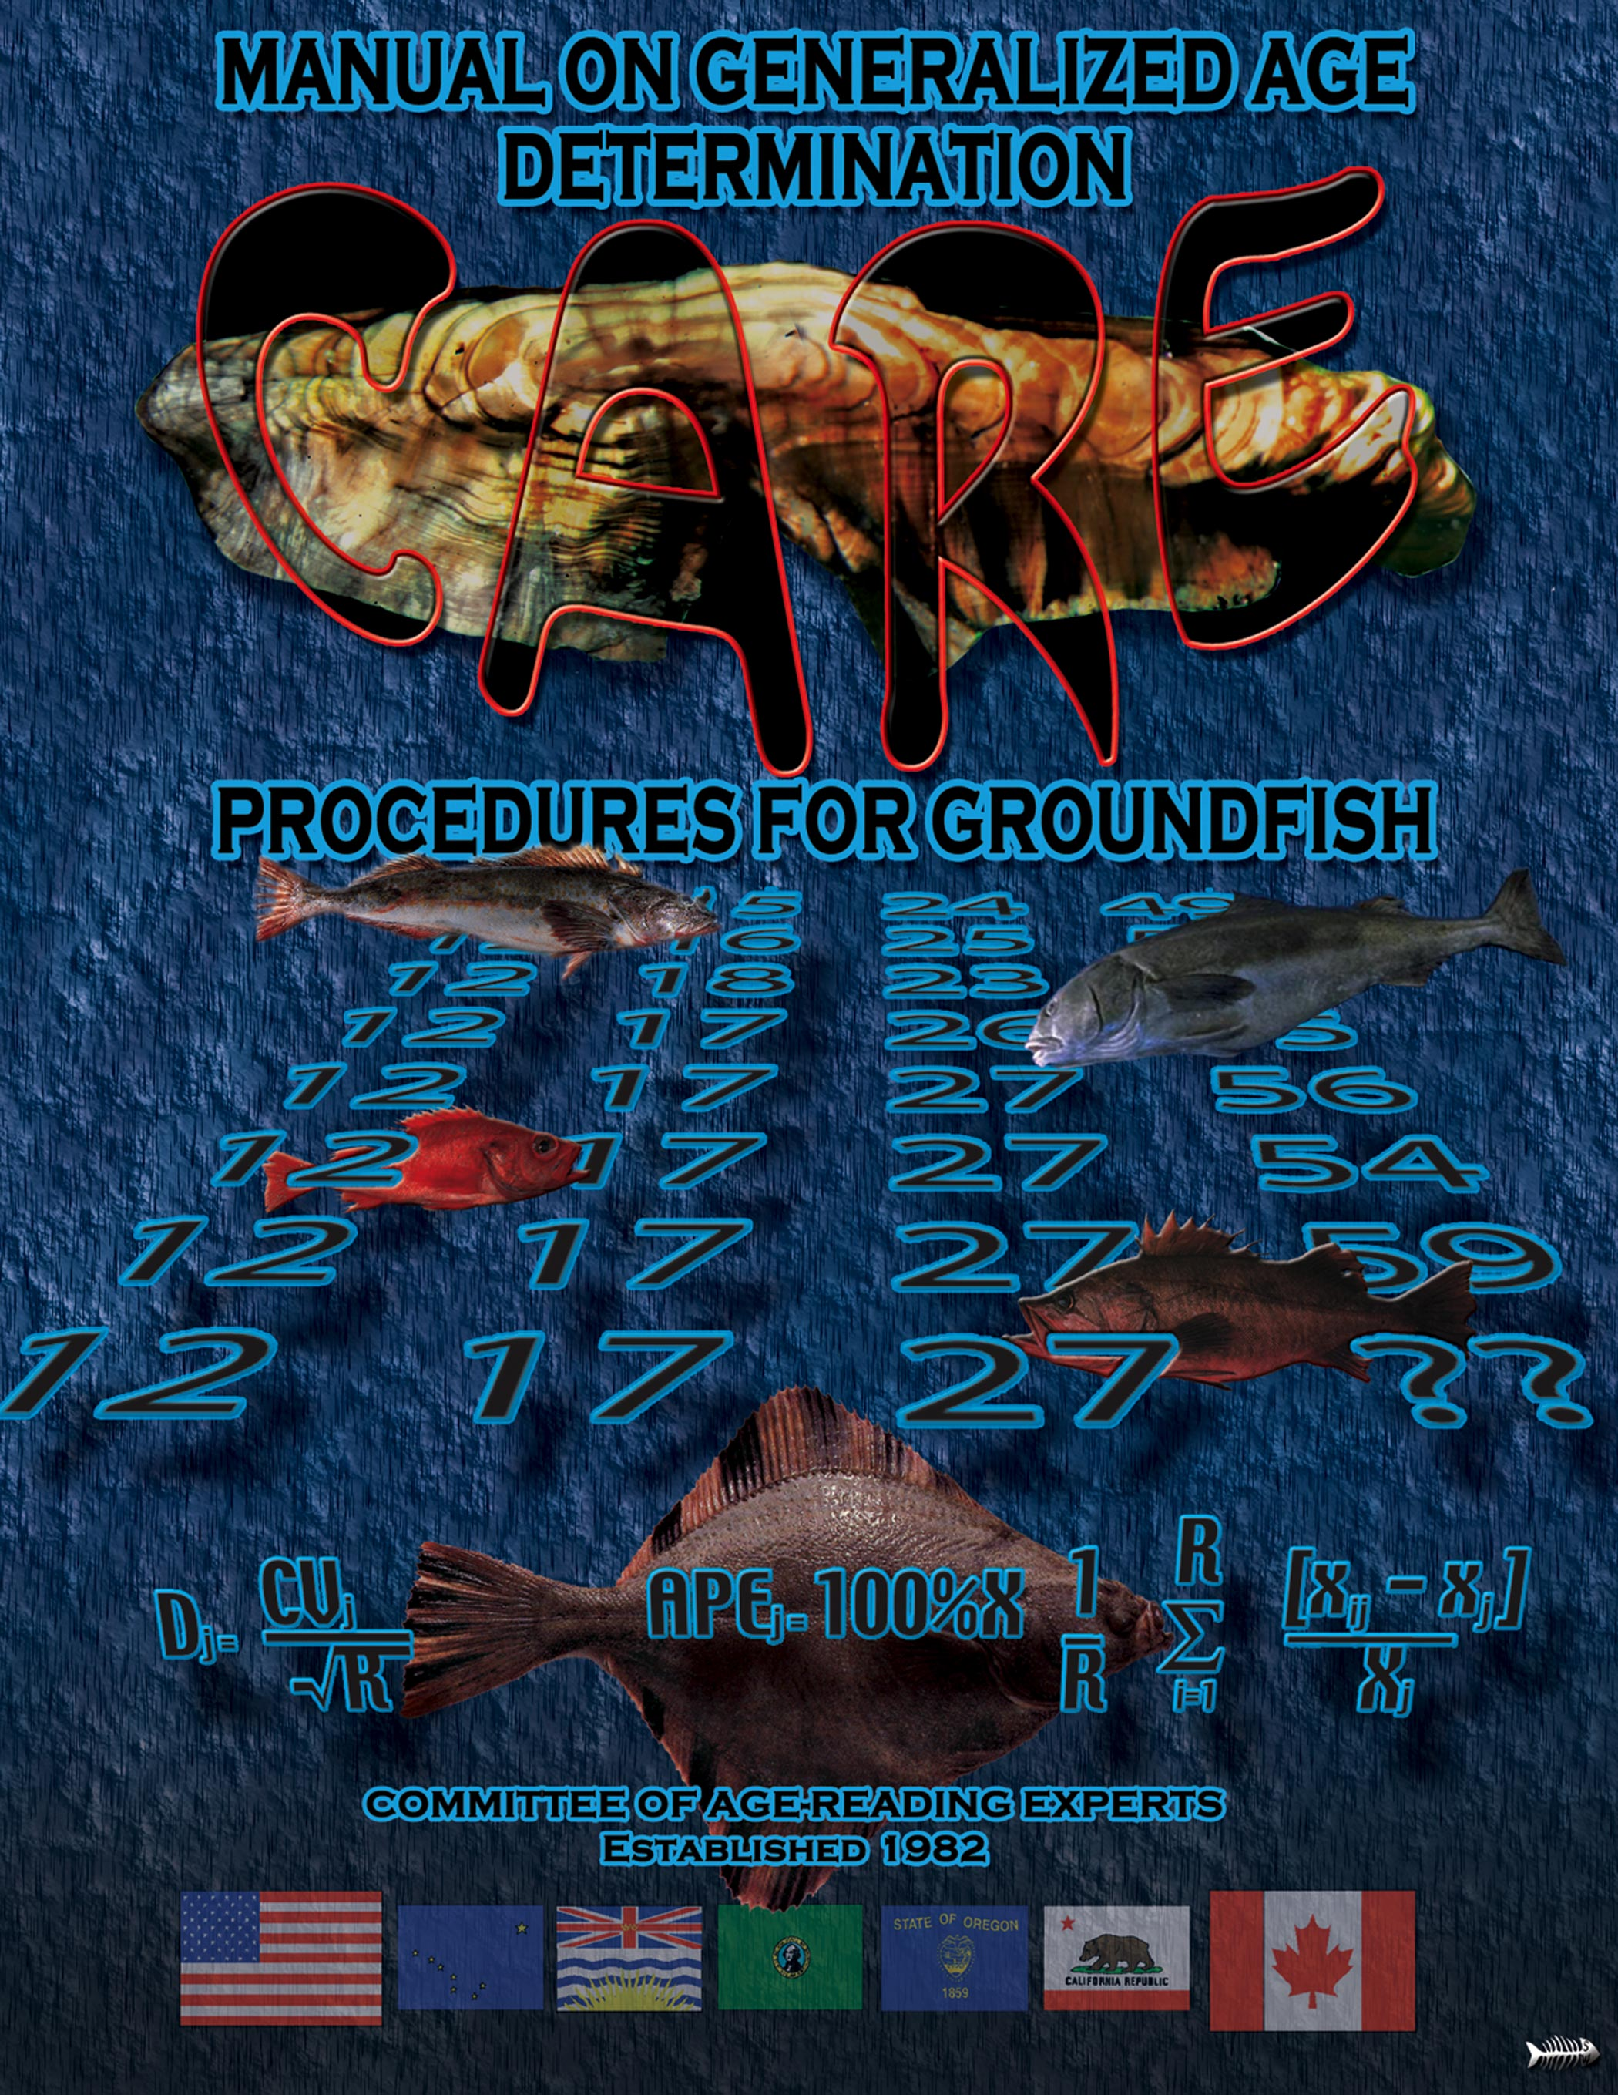

Prepared by:

C.A.R.E.
(Committee of Age Reading Experts)
Pacific Coast Groundfish Ageing Technicians

Under the Sponsorship of:

Pacific States Marine Fisheries Commission

For:

The Technical Subcommittee

of

The Canada/U.S. Groundfish Committee

October 2006
TABLE OF CONTENTS

Participants and Contributers 1
August 1984 Documentation 1
April 1997 Documentation 1
December 1999 Documentation 2
Introduction 3
General Fish Ageing Procedures and Policies 4
Procedures 4
Inter-agency age calibration exchange mechanism 4
Sample size: 4
Sample information: 4
Type of sample: 4
Exchange mechanism: 5
Sample condition: 5
Specific to burnt otolith sections: 5
Ageing technique: 5
Number or type of readings: 5
Age designation: 5
Age recording sheets: 6
Data analysis: 6
Future work: 6
Policies 6
International Birthdate: 6
Accuracy and Precision 8
Validation 8
General Otolith Ageing Procedures 10
Otolith sample collection 10
Summary of otolith storage protocols 10
Permanent storage method for burnt otolith sections 11
Clearing of Otoliths 12
Otolith ageing procedures 14
Methods: 14
Growth zones: 14
Annuli and checks in the juvenile growth zones: 14
Edge type: 15
Rockfish (Sebastes) Ageing Procedures 16
Otolith surface ageing 16
1. Equipment required and magnification: 16
2. Preparation for ageing: 16
3. Axes to count annuli: 17
4. Problems encountered when interpreting growth zones: 17
5. Edge type notation: 18
6. Other procedures: 18
7. Efficiency: 18
8. Assessing confidence in assignment of an accurate age: 18
Otolith thin section ageing 18
1. Equipment required and magnification: 18
2. Preparation for ageing: 19
Mounting procedure: 19
a. Mounting otolith on sectioning card method: 19
b. Embedding otolith in resin method: 20
c. Epoxy-mounting method: 21
Sectioning: 21
i) Using the Buehler Isomet Low-Speed saw to cut sections: 21
ii) Using a Bronwill Sectioning Machine to cut sections: 22
3. Counting axes: 22
4. Criteria used in ageing: 23
5. Efficiency: 24
Otolith burnt section ageing 24
1. Equipment required and magnification: 24
2. Processing for ageing: 24
a. Cleaning the otolith: 24
b. Breaking/cutting the otolith: 24
c. Burning the otolith: 25
d. Positioning the otolith under the microscope: 25
3. Counting axes: 27
4. Criteria used in ageing: 27
5. Other procedures: 28
6. Efficiency: 30
Sablefish (Anoplopoma fimbria) Ageing Procedures 31
Lingcod (Ophiodon elongatus) Ageing Procedures 35
Fin Cross-section Method 35
1. Equipment/materials required and magnification: 35
2. Preparation for ageing: 35
a. Drying 35
b. Hardening 36
c. Sectioning 36
d. Slide Mounting 36
3. Criteria used in ageing 36
a. Annual pattern: 36
b. Growth zone criteria: 37
c. Measurement criteria: 39
4. Efficiency 40
Dover sole (microstomus pacificus) Ageing Procedures 41
Otolith burnt section ageing 41
1. Equipment, materials and magnification: 41
2. Preparation for ageing: 41
3. Counting axes: 42
4. Criteria used for ageing: 42
a. Annual pattern: 42
b. Growth zone criteria: 43
5. Efficiency: 45
Glossary 47
References 49
Appendices 50
List of Tables 50
List of Figures 50

Participants and Contributers

August 1984 Documentation
The rockfish portion and some of the general otolith procedures of this manual were developed during two three-day workshops by C.A.R.E. (Committee of Age Reader Experts) participants. They were sponsored by PSMFC at the NMFS Northwest Fisheries Center in Seattle, Washington on April 27, 28 & 29 and August 3, 4 & 5, 1983.

Workshop participants were:

Bill Barss ODFW Newport, Oregon
George Boehlert OSU Newport, Oregon
Doris Chilton CDFO Nanaimo, B.C.
Tina Echeverria NMFS Tiburon, California
Betty Goetz (rapporteur) NMFS Seattle, Washington
Frank Henry CDFG Monterey, California
Han-Lin Lai U of W Seattle, Washington
Jack LaLanne NMFS Seattle, Washington
Julie Lyons NMFS Seattle, Washington
Shayne MacLellan CDFO Nanaimo, B.C.
Ruth Mandapat WDF Seattle, Washington
Joan Organ ADFG Kodiak, Alaska
Sandra Oxford WDF Seattle, Washington
Charles Woelke (chairman) PSMFC Olympia, Washington
Mary Yoklavich ODFW Newport, Oregon

Observers present:

Lisa Edinger WDF Seattle, Washington
George Hirschhorn NMFS Seattle, Washington

April 1997 Documentation
Addenda and minor text changes to this manual were generated from biennial C.A.R.E. meetings held in 1986, 1988 and 1990. The following were the addenda accepted by C.A.R.E. at the May 16 - 18, 1990 workshop for addition to the existing manual: revised inter-agency age calibration exchange mechanism, sablefish ageing procedures, a summary of otolith storage protocols and a procedure for permanent storage of burnt otolith sections.

Addenda authors and contributors:

Bill Barss ODFW Newport, Oregon
Joan Brodie ADFG Kodiak, Alaska
Betty Goetz AFSC Seattle, Washington
Craig Kastelle AFSC Seattle, Washington
Julie Lyons AFSC Seattle, Washington
Shayne MacLellan CDFO Nanaimo, B.C.

December 1999 Documentation
Three addenda were added to the C.A.R.E. manual in 1999 as the result of the April 1998 biennial meeting. They are entitled International Birthdate, Clearing of Otoliths and Validation. As well, the dates that revisions and additions were made were noted at the end of sections in italics.

Addenda Authors and Contributors:

Craig Castelle AFSC Seattle, Washington
Betty Goetz AFSC Seattle, Washington
Shayne MacLellan CDFO Nanaimo, British Columbia
Kristen Munk ADFG Juneau, Alaska

Introduction
Until recently, very few fisheries agencies anywhere used standard methodology when collecting, storing or determining the age of bony structures used for age determination of fish. The result has been incompatibility whenever cooperative work was required. C.A.R.E.'s task is to document and standardize the ageing procedures used by all age determination facilities on the North American Pacific coast.

C.A.R.E. is also concerned with setting up mechanisms which make it possible to exchange samples for the purpose of calibrating the precision of age determinations between agencies. This includes information on how to make up samples for exchange, as well as a way to preserve permanent collections of specimens for precision testing.

The intention is that this manual will continue to evolve over time. It will document any changes to old methodology recommended by the committee or record any advances in groundfish ageing technology that will contribute towards improving the quality and standardization of fish age determination.

April 1997

General Fish Ageing Procedures and Policies

Procedures

Inter-agency age calibration exchange mechanism
Age structure exchanges between agencies occur for various reasons. It is important that these goals are kept in mind when structuring the exchange. Measurement of accuracy (true age) is not considered in this mechanism, as known-age fish are required. The two more common purposes for such exchanges within C.A.R.E. are:

1. Determination of the level of precision (agreement or repeatability) of age determinations among different Pacific Coast fisheries management agencies.

2. Evaluating the degree of ageing biases within the readers of different agencies.

Once precision is established between readers and agencies, cooperative efforts can be established to overcome differences. C.A.R.E. recommends that agencies should resolve these differences on a one-to-one personal basis. It cannot effectively be done by long distance.

The level of expertise of the participating readers is an important aspect which should be taken into consideration when structuring the exchange. Between-agency exchanges are not recommended for novice readers, unless the object is to assess their progress in a training program. C.A.R.E. recommends that all initial training should be done on a personal one-to-one basis.

A pilot exchange study was completed by C.A.R.E. in 1984-85. The results indicated that certain procedures are to be recommended to ensure the success of future exchanges:

Sample size:
It is recommended that a maximum of 100 structures be exchanged. More than this becomes logistically difficult to deal with. Too large a sample extends the amount of time each reader must spend ageing it, within reasonable time limits, and interferes with their own work timetable. There is a strong need for more research to investigate the number of fish that should be aged when assessing precision.

Sample information:
The date of capture must be provided for each structure, and each must be clearly labelled with an unambiguous specimen number. LENGTHS ARE NOT RECOMMENDED AT THE TIME OF AGE DETERMINATION.

Type of sample:
Sample type depends on the goal of the exchange. Samples should be representative of what is being aged on a production basis or embody specific interpretive problems.

Exchange mechanism:
For general purposes, it is recommended that participants avoid exchanging samples caught during June and July. Interpretation of edge growth is often difficult at this time. Under or over-ageing by one year is a common result. Agencies trying to resolve "edge interpretation" problems should determine differences using a "hands-on" workshop method.

Sample condition:
In order to maintain sample integrity, each structure should be stored in an individual container such as snap-top plastic/glass vials, envelopes, etc., and labelled with appropriate information. All structures should be packaged carefully for transportation and stored in the proper media recommended.

Specific to burnt otolith sections:
Where more than two agencies are involved, comparability of ages may be compromised by mechanical damage through handling or fading of the burnt pattern. Both otoliths should be included. To determine the best age possible, the agencies may be forced to burn all 4 otolith halves. Therefore, until a quick, efficient permanent preservation method is established for this method, it is recommended that no more than two or three agencies be involved with each exchange.

Ageing technique:
Use the techniques and structures of choice for each species. This will depend upon the comparisons desired, i.e., comparison of different structures or methods to age the same species, or comparison of the same method between different agencies.

Number or type of readings:
The number or type of replications depends on the goal of the exchange. Replicate independent readings must be recorded on separate data sheets. If readers are including self-tests, enough time must be allowed in between to avoid recognition of individual ageing structures.

If the purpose is to calibrate between agencies or methods, each agency should provide age data that is produced by their own standard procedures. This might include single reader or double reader age determination systems and whatever precision testing is done. The number of replicates depends on the regular practice of each group. Basically, only the end product of one age from each agency or method is compared.

If the purpose is to ascertain reader biases within and between agencies using the same method, a minimum of 2 independent readings is required.

Age designation:
Age designations (number of annuli) should be recorded as described in Chilton and Beamish (1982), using the internationally accepted birthdate of January 1st. To aid resolution of ageing conflicts, the last growth zone present on the structure's margin should be described with one of the following descriptions:

1. annulus/winter zone on margin
2. summer growth starting on margin
3. moderate summer growth on margin

It is recommended that each age determination be accompanied by a "readability" assessment in order to give the age data users an idea of the quality (or error) of each age. The confidence in an age assignment and its closeness to the true age is usually determined by the ease with which the growth pattern is interpreted. To describe this confidence, a readability index has been adapted from that used by the Fish Ageing Lab at the Pacific Biological Station, DFO, Canada:

Good - The reader feels that an identical age would be produced with replicate readings, i.e. a very clear growth pattern.
Fair - Replicate readings would be always within, eg. 1 year. This should be established for each species.
Poor - Considerable variability from replicate readings.

Age recording sheets:
Readings should be recorded on standard age data sheets that have been agreed upon by the agencies involved. This facilitates consistency of age data documentation and helps to avoid confusion between recording methods.

Data analysis:
Depending upon the purpose of an exchange, a preferred data analysis technique can be selected (e.g. percent agreement). This should be discussed by the agencies involved. To expedite the data analysis, the exchange coordinator should take responsibility for collecting the completed data sheets in a timely manner.

Future work:
One of C.A.R.E.'s proposals is to establish permanent reference collections of age structures for those agencies requiring them. For the burnt otolith section technique, the feasibility of such a collection hinges upon the development of a treatment which preserves the quality of the burnt otolith. The Barss Method of resin casting shows great promise (see the section on Generalized Otolith Ageing Procedures). However, further evaluation of this treatment is necessary before long-term preservation of burnt sections can be used.
April 1997

Policies

International Birthdate:
By international convention (Williams and Bedford, 1974), the birthdate of fish has been assigned as January 1st, regardless of hatch date. A fish age-reader must assign a fish to its proper age class according to the date it was caught with reference to this birthdate. To do so the reader must judge in which year growth seen on the edge of an otolith was formed. At some times of the year, this decision is relatively straightforward. For example, if an otolith from a fish caught December 31st shows either a full year’s opaque growth or an annulus (translucent material) forming on the margin, the reader would automatically attribute this growth to the catch year. Thus, the edge growth would not be counted in the fish’s age. If this same fish were caught one day later, January 1st, it is assigned an age which is one year older. The edge growth is attributed to the previous growth year and therefore is counted. Assigning otolith edge growth from a fish captured from May through August may not be as straightforward and requires knowledge of typical growth tendencies of specific species. See Figure 1 below for further explanation.

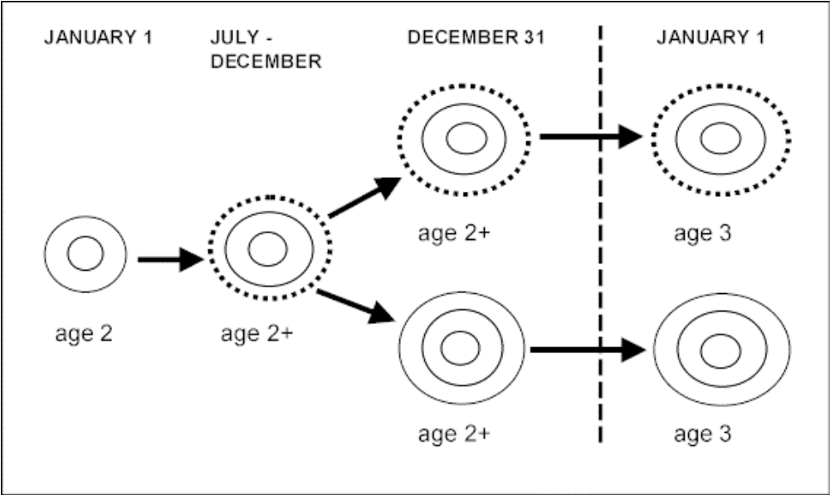
Figure 1: These drawings represent an otolith showing growth stages from one January to the next. Growth timing by month may very somewhat between species, stocks, years or locations. The solid black lines represent the translucent annuli (slow growth) which alternate with wide white zones representing opaque zones (fast growth). The dashed lines designate incomplete opaque growth. The intermediate growth stage from July through December may show a varying amount of new opaque growth on the otolith margin. The 3rd stage presents two possibilities where an annulus may or may not have started to form late in the year following the deposition of lots of opaque growth. Regardless of the type of growth (opaque or translucent) formed at the otolith margin, the age class advances by one year upon January 1st.

December 1999

Accuracy and Precision

Validation
Validation is a process that proves the accuracy of a fish age determination method. Until validation studies are carried out, a method cannot be considered to be accurate. In the past, many have mistaken good precision (repeatability) for accuracy (Beamish and McFarlane 1983). Since the mid 1980’s, more and more agencies and individuals involved with fish age determination have come to understand the importance of validation and have taken steps to assess the accuracy of their methodologies.

The method of validation can be direct or indirect. Direct validation involves the use of known-age or partly known-age fish. These methods include:

- Chemical marking: An internal “time mark” is incorporated into the calcium carbonate structures (bones) during mark-recapture studies. The fish are injected with a fluorochemical compound and may also be tagged externally. There are a variety of fluorescing chemicals available, for example, oxytetracycline and alizarin complexone. Upon recapture, age structures are retrieved and the number of annual zones formed after the chemical marker are estimated and compared to the time-at-liberty.
- Coded wire tags (CWT): These tags are most commonly used for marking hatchery and wild salmon fry and smolts, as well as some other fish species. The CWT is a small length of wire, generally 0.5-1.0mm, which is laser-cut with a specific binary code sequence. This discrete code is cross-referenced to the known release parameters.
- Thermal marking: This is a fish mass-marking method used in salmon hatcheries to discretely identify a population of fish by encoding a series of pronounced growth increments, called thermal rings, into the otolith. Water temperatures are cycled by 4 degrees centigrade which causes the fish to deposit sharply contrasting levels of calcium carbonate and protein. When cycled according to a specific schedule, a discrete pattern is created, called a thermal mark code.
- Natural tags: These tags are created when pronounced fluctuations in the environment produce growth zones which appear atypical or contrast with preceding or succeeding growth. They are identified through careful evaluation by experienced fish age-readers. The tag identifies a year class which may then be tracked over time.
- Radiometric assessment: This process measures the relative proportions of radioisotope pairs found in the otolith and estimates a close approximation of age. Laws of physics describe known decay rates of specific pairs. For example, radium (Ra) enters the fish through normal metabolic processes. This element takes a known number of years to reduce itself by half (half life). The proportion of decay product is determined through laboratory assay, with proportions indicative of elapsed time. For potentially long-lived fish (>60 yr), 210Pb/226Ra is used to measure age, while 238Th/232Th is used for species that are believed to live less than 10 years.
- Radiocarbon dating: This technique evaluates fish born between 1955 and 1985. It measures the increase of radiocarbon in the environment as a result of prolific nuclear testing in the 1950’s and 1960’s and is referred to as a “radiocarbon bomb chronometer”. It measures the amount of radiocarbon taken up into the otolith during the first year of birth. Plotted on a scale of known increasing levels of 14C, the results indicate an approximate birthyear.
- Juvenile fish of known-age using length-frequency information or through rearing in-situ: Fish can be tagged externally and recaptured to estimate total age and years at-liberty with respect to age at-tagging.

Indirect validation estimates age by measuring the frequency of occurrence of various parameters:

- Length-frequency modes: A predominant occurrence of a range of lengths identifies age classes. This method works best in identifying the annual growth zones of fast-growing juveniles. It is less accurate when growth of the fish slows, especially with long-lived species.
- Marginal increment analysis: This procedure measures the formation of growth formed on the growing edge of an otolith by looking at monthly samples taken during one year. It verifies that one annual growth zone (one opaque zone + one annulus) forms over the course of one year.
December 1999

General Otolith Ageing Procedures

Otolith sample collection
The state in which an ageing sample is received by fish ageing technicians can have a great effect on the reader's ability to produce quality age data. Since sample quality is so important, the following recommendations were made by C.A.R.E:

Collection of samples:

- Samples must be properly identified and individually labelled. Waterproof paper is preferred. Required information includes: species, length, date caught and sex. Other collection information (i.e., area, cruise, etc.) can be specified by the individual study.
- Extraction of both otoliths is recommended.
- Cleanliness of otoliths is of critical importance to the age determination process. All external organic attachments must be removed. This can be accomplished by rubbing the otoliths over cotton (eg. glove) and/or submerging them in a container of water.
- Leak and break-proof containers (eg. snap-top plastic vials) are recommended. Each pair of otoliths should be placed in individual containers. The discreetness of each fish sampled must be preserved. Samples may be collected and transported with or without a liquid storage medium.
- Individual specimen numbers should be assigned and placed inside storage containers. A permanent marker is recommended. Specimen number labelling on the outside of the container is also useful. This will allow cross-referencing of the sample with appropriate length, sex, and weight data taken from each fish.
April 1997

Summary of otolith storage protocols
At this time there is no consensus as to the most appropriate storage method for otoliths. Therefore, the various techniques of each C.A.R.E. agency, as of 1990, have been listed in Table 1. Each method has its advantages and disadvantages.

Cautions:

- Dry storage can cause otoliths to become brittle and opaque. Storage in envelopes, except for small, sturdy otoliths like Dover sole, can result in breakage. Otoliths stored dry in trays can fall out if shipped.
- Otoliths stored dirty will deteriorate and become unreadable. Opportunities for mold to grow are increased when organic material is left behind. Wipe all organics away.
- Otoliths dipped in chlorine bleach for a quick cleaning become brittle, even when rinsed in fresh water.

Agency | Species | Medium | Container/Package
AFSC | flatfish  others | glycerin and thymol  EtOH | flip-top plastic vials# and glass vials with screw caps lined with plastic (not coated paper)  flip-top plastic vials and glass vials with screw caps
ADFG | all | dry | trays, envelopes, vials and small zip-lock bags*
CDFG | all | dry | glycerin capsules, envelopes*
IPHC | halibut | glycerin and thymol⁺ | trays, vials and envelopes, with new emphasis on plastic vials
WDF | all | dry | envelopes, may go to vials
ODFW | rockfish  Dover sole,  sablefish, some others | EtOH 50%  dry | plastic vials with lids sealed with paraffin  trays
CDFO | all | glycerin and thymol⁺ | trays
Table 1: Agency otolith storage protocols as of 1990.

# can snip cap connectors for more secure seal
* Preferred method
⁺ Glycerin recipe for otolith storage:
2 litres glycerin
2 litres water
5.5 grams of thymol (crushed)
Use enough alcohol to dissolve thymol (about 20 ml). Measure out the thymol and add it to the alcohol. Once the thymol is completely dissolved, add it to the glycerine only, and shake vigorously. Then add the water.

April 1997

Permanent storage method for burnt otolith sections
A disadvantage to the burnt otolith section ageing method is that the clarity of the growth pattern is not permanent. After burning, there is a tendency for "fading" in the clarity of the burnt pattern. It is not known what causes this. There is no predictability as to species or individuals with regards to the time factor involved. It can occur over hours, days, weeks, years or sometimes not at all. Generally, it appears that smaller or more lightly burnt otoliths are more likely to fade, and sooner, than larger or more darkly burnt otoliths.

C.A.R.E. has been concerned that the burnt otolith method could not guarantee permanent storage of patterns for future reference. It was recommended that investigations take place to overcome the problem. Studies revealed that permanent storage of broken and burnt otoliths could be attained by surrounding the otolith with clear casting resin. Burnt otolith patterns have stayed clear for up to five years using the following method (Bill Barss, Oregon Department of Fish and Game):

The Barss Method of permanent otolith storage:

- Label the side of an 8 ml capacity translucent polyethylene vial (an electric pencil engraver is recommended).
- Fill the vial with modelling clay to the depth of about 5 mm (green or blue recommended).
- Cut/break the otolith through the nucleus on the dorso-ventral axis.
- Burn the cross-section to the desired darkness. Do not put oil on the section surface of the otolith.
- Place the cooled otolith into the vial with the section surface "up" and extending about 5 mm above the clay.
- In a fume hood, prepare a clear casting resin.
- Cover the otolith surface to a depth of about 5 mm.
- Remove bubbles in the casting by placing the vial on a shaker before the resin solidifies.
- Place the lid on the vial and store on a flat surface to harden. To prevent marking, do not touch the casting resin surface until it is set hard.

Clearing of Otoliths
The technique of “clearing” otoliths is used to improve the visibility of annuli on the distal (aka lateral) surface of otoliths (Figure 2). The otolith-surface method is often used to age fast-growing species. Their otoliths tend to have wider spacing of annuli on the surface in the dorso-ventral plane. Clearing is not generally used for species which are slow-growing and long-lived because there is insufficient resolution of annuli. Also, later annuli are generally not visible on the lateral dorso-ventral surface. Because of the concern for under-ageing, most species are read using cross-section (sagittal-transverse) techniques. However, for fast-growing, shorter-lived species, surface age-reading offers the advantage of producing age estimates with reduced labor.

Clearing involves immersing the otoliths in a solution that reduces relative opacity of the entire otolith. Many solutions may act as clearing agents, for example water, ethanol, or glycerin. Ethanol and 50% glycerin are most commonly used, and often double as a storage media. Pharmacy-grade glycerin (100%) is diluted with water by half. A “pinch” of thymol is diluted in 20ml of ethanol and added to the solution to inhibit bacterial growth. Before each use of this solution, the container must be agitated to distribute the thymol.

The length of time required to clear an otolith is dependant upon when it is immersed in the solution. Otoliths collected from fish are in a hydrated state, and if put immediately into ethanol or glycerin are immediately ready for age-reading. Otoliths which have been allowed to dry, and then placed into ethanol or glycerin will require a few to several weeks to clear. This depends upon the species or size of the otolith. For example, dry lingcod otoliths require a minimum of 6 weeks of clearing before annuli are consistently legible. An otolith which has become cleared enough for evaluation will continue to clear over time. Some species may become “over clear” (perhaps taking several years) where no annuli are discernible due to maximum uptake of glycerin.

Clearing of otoliths is a useful process. But, before its use, sample or stock parameters like species lifespan, required turnaround time for data, comparative precision to other techniques and permanence of the effect of the clearing solution must be considered and evaluated. Drawing on the experience of others as to what age determination-reading technique is best for what species circumvents this involved process.

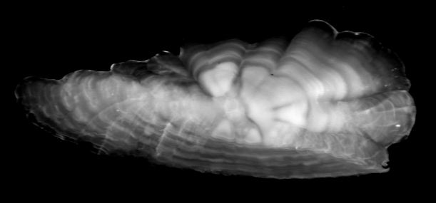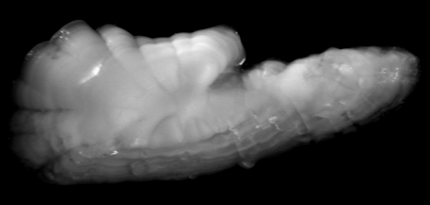
Figure 2: Distal surface view of a pair of lingcod sagittal otoliths, under reflected light. The top otolith has been cleared while the bottom otolith has not been. Note the distinct annuli (dark zones) of the cleared otolith in comparison to the one that has not been cleared.

December 1999

Otolith ageing procedures
When ageing specimens from a new species, stock or locality, it is essential to collect samples that are representative of the entire age range of the population. Samples should be obtained throughout the different annual seasons and over a broad spectrum of size classes so that the progression and pattern of annulus formation is apparent for the species in question. In addition, novice fish ageing technicians should be cautioned that growth anomalies (and resulting interpretative difficulties) may arise in specimens from differing stocks and/or localities.

Methods:
The two most common methods used to age otoliths are surface and cross-section. It has been demonstrated (Christensen 1964, Power 1978, Beamish and McFarlane 1987) that examination of the otolith cross-section is necessary to more accurately determine ages for longer-lived fish. Examination of the surface only can result in errors (under-ageing). It is therefore recommended that initially careful comparisons of ages be made using both surface and section methods to decide at what age it may become necessary to section the otolith. However, with reference to standardization and comparisons, it is advisable to decide on the use of the method that is capable of ageing the entire age range of the species in question.

In making this decision, consideration should be given to the early natural life history of each species, particularly the age of reproductive maturity. The otolith surface method should not be ignored. It still has an important role to play as a supplement to section ages. It can be very useful as an aid to identifying the first several annuli.

Growth zones:
There are three basic growth zones that all readers must learn to identify, whatever the age structure they are ageing. These are the annuli (winter zone), checks and summer zones. Their definitions can be found in the glossary at the back of this manual. In developing an otolith ageing method, there are three potential problem areas that are likely to arise involving these zones. These are in the identification of the first few annuli, interpretation of growth checks, and determination of the type and amount of current year's growth at the otolith margin.

Annuli and checks in the juvenile growth zones:
Accurately identifying the location of the first annulus is critical and it must be validated. On otoliths, it often has shape and size characteristics that set it apart from succeeding annuli. Researchers must collect otoliths from juveniles, especially ages 0+ to maturity, to establish length frequency modes for the fast growing phase of a species' life. The first and subsequent few annuli should normally be possible to identify as a result. It would also be helpful to collect samples over all months of the year to establish time of annulus formation. Measurements of annual zones can be useful. However, one should be aware that growth could vary between stocks and cohorts, as well as between sexes and individuals.

The large size of early growth zones on otoliths represents the juvenile fish's years of rapid growth. In this region of the otolith, checks are often nearly as prominent as annuli. Checks form for the same reason as annuli because of a slowing of growth and therefore look similar. It is useful to know the early life history of a species, as checks may occur when there is a change in diet, depth or habitat. Establishing the first few annuli, as described above, should help to identify the time of formation and characteristics of checks. The aim of developing annulus criteria is that they should be powerful enough to permit the reader to assign a consistent age, with confidence, most of the time.

Edge type:
Interpretation of the current (year caught) summer growth zone at the margin of the otolith is crucial. By convention, the birthdate of all fish is considered to be January 1st. It is necessary to know the month of otolith collection and time of annulus formation in order to accurately assess the year in which growth on the margin was formed. Age class is assigned according to this protocol and is dependent on the amount of growth present.

In the North-West Pacific region, edge type is particularly critical for samples caught between early fall (Sept.) and late spring (June). Depending on the species, large amounts of opaque growth may be present on the otolith margin throughout this time. By convention, an otolith with a large amount of opaque growth on its margin is not considered to be a year older until January 1st (Chilton & Beamish 1982). New (catch year) growth can also be difficult to interpret early in the growing season (June-July). This is especially true for otoliths from older fish. Specifically, the reader may have a difficult time deciding which year of growth to attribute the margin growth to, the previous or current. Whatever the case, misinterpretation of edge growth can easily cause an ageing error of one year.

August 1984
Revisions & additions April 1997

Rockfish (Sebastes) Ageing Procedures
The procedures outlined in this section may be applied to age determination of all rockfish species, except where noted. The sagittal otolith (subsequently termed "otolith") is the preferred structure for ageing rockfish species. Surface and thin and burnt section ageing methods are described.

Otolith surface ageing

1. Equipment required and magnification:
Use high-quality optical (i.e. Wild) binocular microscopes M3, M5 and M8 with 10-100x magnification.
Use high-intensity lighting, preferably fibre optic lamps.
An eyepiece micrometer may be useful.

2. Preparation for ageing:
For contrast between translucent and opaque zones, submerge otolith in clear media (such as water) in a petri dish with a black background. This will cause translucent zones to appear darker. Avoid the use of media that is considered toxic. The purpose of liquid in the petri dish is to reduce glare on the three dimensional surface of the otolith (Fig. 3 a, b).

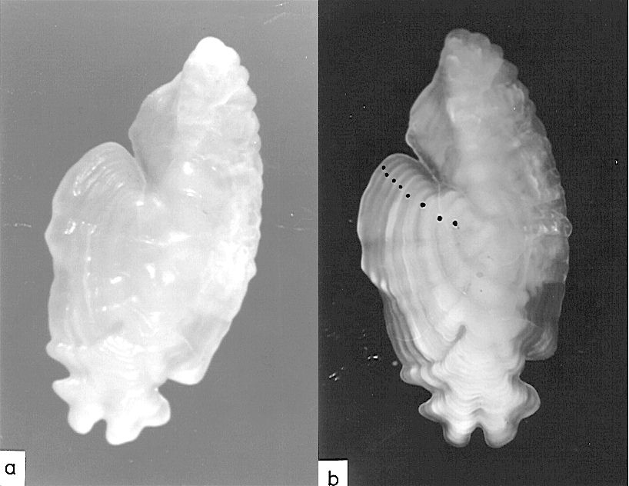
Figure 3: a) Distal surface of a dry S. alutus otolith, illuminated by reflected light.
b) Same otolith as in a) submerged in water. Note that the annuli (dots) are much clearer than in a).

3. Axes to count annuli:
View the otolith surface with the concave (distal) surface facing upward. The areas of an otolith that are easiest to read depend on the species. In most cases, the posterio-dorsal, posterior and ventral axes are preferred (Fig. 4).
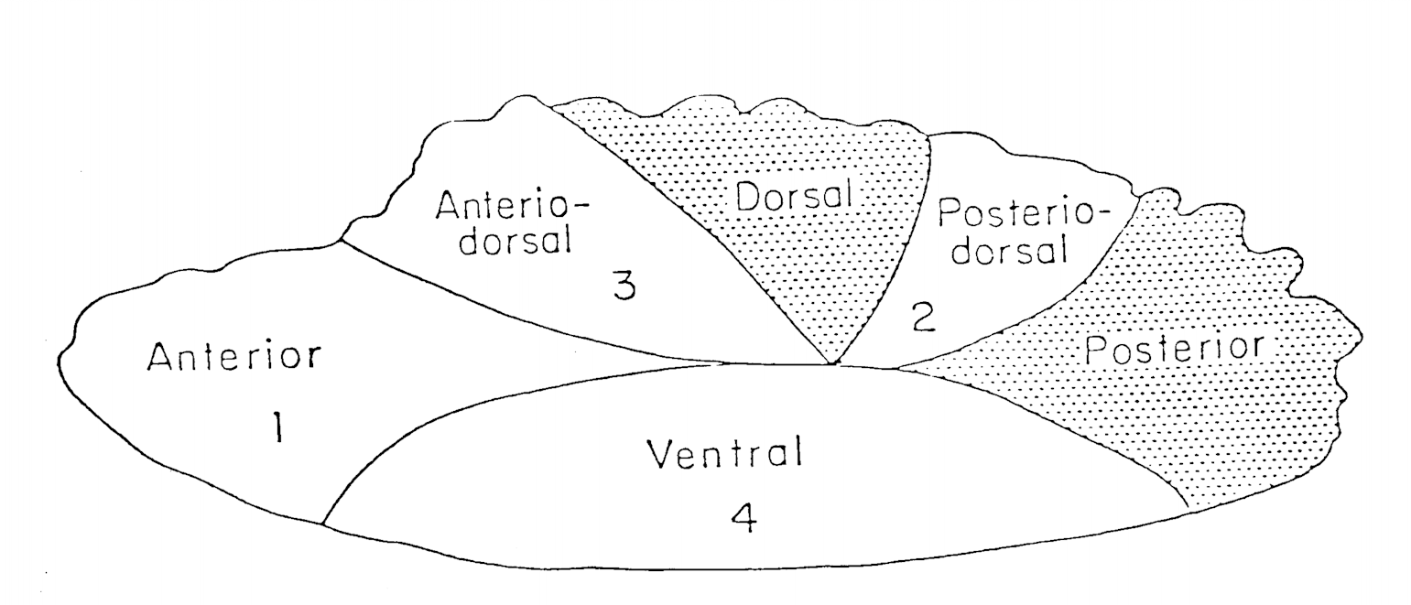
Figure 4: Drawing of a rockfish otolith, distal/concave surface up, showing various axes used during age determination.

NOTE: For chilipepper rockfish (Sebastes goodei), the anterio- and posterio- ventral axes are preferred.
For widow rockfish (S. entomelas), the anterio-dorsal axis is preferred.

Consistent counts are most easily made from the nucleus to the outer margin on young otoliths. On older otoliths, count translucent zones from the margin toward the nucleus. To view older otoliths, it is necessary to tilt and roll them from side to side to view the margin from the dorsal view. A reader should attempt to obtain identical counts from two areas before assigning an age. When counts from two areas disagree, it may be necessary to examine a third area to obtain agreement.

4. Problems encountered when interpreting growth zones:
a. narrow opaque zones (a zone narrower than the preceding and succeeding zones)
b. "doubling" (two opaque zones appear close together with only a faint translucent zone separating them)
c. prominent translucent zones formed within the first year

These problem areas are very subjective in nature. It is important to be consistent in identifying such zones as annuli or checks and to document the reasons for doing so.

5. Edge type notation:
Edge type notation is used by some agencies to help describe current year of growth on the otolith margin of fish less than approximately 10 years:
0+ = relatively narrow opaque zone
0++ = relatively wide opaque zone
T- = translucent zone incomplete

6. Other procedures:
Otoliths may be dipped in 10% hydrochloric acid solution to remove dirt or chalky film on the surface that interferes with identification of translucent zones. The recommended time is for 2-3 seconds. Longer immersion may dissolve portions of the otolith and growth zones may be lost.

7. Efficiency:
A daily average of approximately 50-100 otoliths can be assigned final ages. Speed and accuracy depend on the species. Factors involved are: clarity of the otolith pattern, the general age composition of the sample (old, young, or mixed group) and the skill level of the reader.

8. Assessing confidence in assignment of an accurate age:
Variations in environmental conditions in different collection areas result in a diversity of growth patterns. The rockfish species examined during the April 1983 workshop were rated according to general difficulty in age determination. This rating appeared to hold true for samples collected in California, Oregon and Washington, but is not indicative of the order of difficulty seen in other areas (ie. Canada):

Order of difficulty:

1) Pacific Ocean Perch (S. alutus) - most difficult
2) Canary Rockfish (S. pinniger)
3) Yellow Rockfish (S. flavidus)
4) Chilipepper (S. goodei)
5) Widow Rockfish (S. entomelas)
6) Black Rockfish (S. melanops)
7) Bocaccio (S. paucispinis) - least difficult

Otolith thin section ageing

1. Equipment required and magnification:
The Buehler Isomet low-speed saw or Bronwill high-speed sectioning machine are recommended. With the resin embedding method, a jeweller’s saw may also be used.
Polishing sections, if desired, may be accomplished using a very fine grade of wet-dry sandpaper (400 - 600 grit carborundum) or jeweller’s rouge.

Compound or dissecting microscopes may be used, provided they have the necessary magnification. A range of 25 - 200x magnification is needed. High-quality optics are critical to achieve precision in otolith section ageing.

2. Preparation for ageing:
The otolith must be thoroughly dry prior to sectioning. If the otolith is stored in ethanol/water, towel and air dry. If stored in glycerine/water, towel dry, then dip it in toluene to remove all traces of the storage medium. This will require good ventilation (fume hood) due to toxic fumes.

Mounting procedure:

a. Mounting otolith on sectioning card method:
- Use Dennison double-thickness tags (No. 12-104-1).
- Draw intersecting lines on the tag (Fig. 5).
- Label the tag with unique otolith identification data.
- Place a 1 cm piece of double-sided adhesive tape at the center of the tag.
- Place the otolith on the tape, centering the otolith's focus directly over the tag line intersection.
- It is very important to orient the otolith properly, with its dorso-ventral axis on the long axis of the tag (Fig. 5).
- Pour the mounting medium around and on top of the otolith.
- Any of the following mounting media are satisfactory:
- Clear plastic casting resin.
- Finger nail mender.
- Clear, hard epoxy-based resins.
- As the mounting media gels and hardens slightly, trim away excess media to the edges of the otolith with a razor blade.
- The mounting medium must be completely hardened and dry before sectioning (overnight/24 hours).
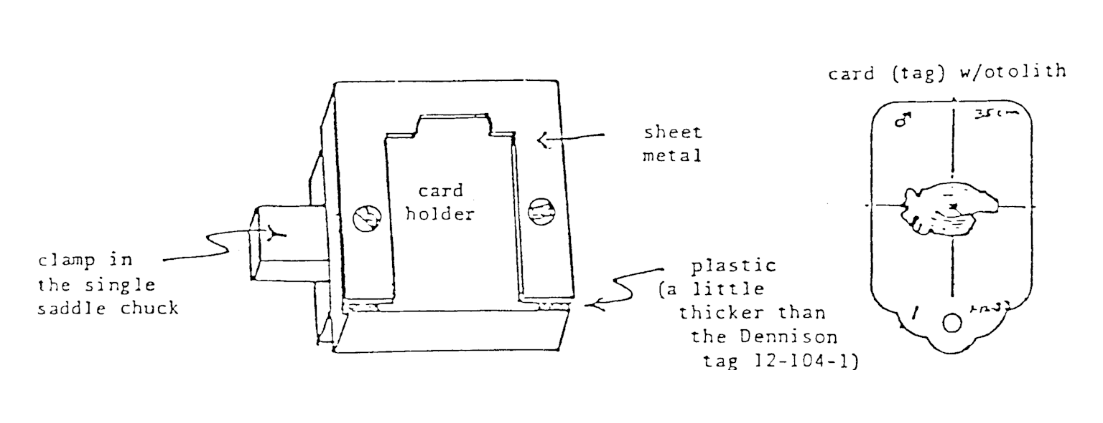
Figure 5: Single saddle chuck and Dennison double-thickness tags used when mounting an otolith on a sectioning card. Note orientation of the otolith on the sectioning card.

b. Embedding otolith in resin method:
- Mark the otolith nucleus with a pencil to facilitate alignment on the sectioning saw.
- Prepare a small specimen label (1.5 cm square) from paper and use indelible ink to record identification data.
- A semi-circular PVC trough-like mold (approximately 2.5 cm wide x 2 cm deep) is used in lengths of 25-30 cm (PVC mold accommodates at least 12 rockfish otoliths).
- Lightly wax the interior of the trough with a paste wax to facilitate removal of the cast resin, followed by the plugging of the trough ends with corks.
- Pour a thin, 5-7 mm thick layer of clear casting resin into the mold and allow to gel. This layer provides a base to support the otoliths.
- Place each otolith along its longitudinal axis on the resin base, along with its respective label. Care should be taken to align the otolith along this axis to ensure a perpendicular dorsal-ventral section.
- Pour casting resin over the otolith, completely covering the structure. Allow to harden for 24 hours.
- Remove resin bar by twisting the PVC mold slightly.
- The embedded otoliths in the resin bar may be sectioned, employing any of the thin-sectioning equipment described below.

c. Epoxy-mounting method:
Refer to Chilton and Beamish (1982) for a description of the epoxy-mounting method.

Sectioning:

i) Using the Buehler Isomet Low-Speed saw to cut sections:
Double-blade:
- Place chuck in correct position (11-1184 single saddle chuck).
- Place card holder in the chuck to pass the blades through the focus of the otolith on the card.
- Place two blades (blue writing on the blades should face each other) on the saw with acetate or brass spacer between the blades.
- The separator should be about 1.5 cm smaller in diameter than the blades.
- Use sufficient spacers to produce sections 0.5 mm thick.
- Adjust the stop on the card holder arm so that the machine stops just as it cuts into the Dennison marking tag (card).
- While sectioning, keep the cooling bath full of distilled water. The addition of a small amount of liquid soap aids in lubrication.
- Place a card with embedded otolith in the card holder.
- Adjust the hold so that the focus of the otolith will be centered on the cutting blades.
- Slowly lower the otolith onto the blades.
- Start the saw at a setting of about 7.
- A medium-sized weight should be on the chuck holding arm or the cutting will be too slow.
- Increase cutting speed to 10.
- The machine will stop automatically.
- Remove the otolith card and extract the section with forceps.
- If a portion of the section is missing, it may be between the saw blades or in the coolant bath.
- Keep the blades sharp, otherwise, the speed of sectioning will decrease.

Single blade:

- Following the first cut, position the otolith for the second cut by advancing the micrometer 20 micro-units (produces a section about 0.4 mm thick). A slow cutting speed of 3 is recommended.

ii) Using a Bronwill Sectioning Machine to cut sections:
- Encase otoliths in epoxy for support during the sectioning process (Chilton & Beamish 1982).
- Section otoliths 24 hours after embedding in epoxy.
- Clamp the otoliths in the chuck of the Bronwill Machine.
- Cut several sections of about 0.5 mm and place on a slide.
- Place histological mounting medium at the center of the slide, using about one drop and place sections on drop.
- Cover entire surface of otolith section with mounting medium.
- Allow to dry overnight and store in slide boxes or trays.

3. Counting axes:
The preferred axes of reading may vary among rockfish species. For most, they can be traced on the dorsal side, from the nucleus to the proximal/internal surface edge (areas I,II & III in Fig. 6). Counts should be determined twice, preferably on different axes or areas. Begin ageing first years with a lower power and increase magnification if necessary to identify the much narrower annuli that are formed as the fish ages.
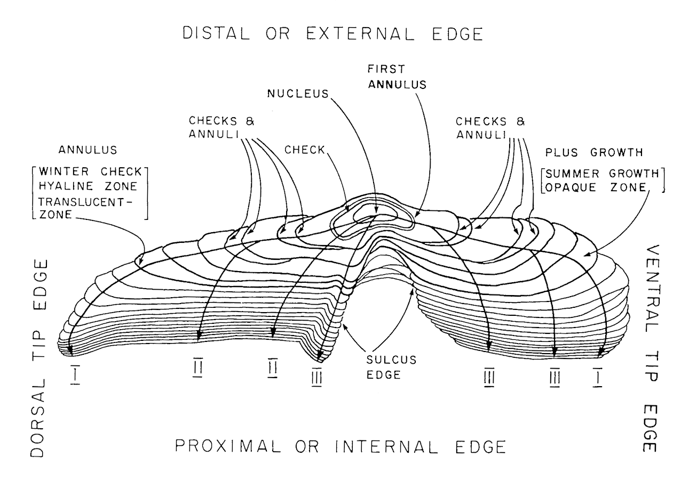
Figure 6: Drawing of a rockfish otolith cross-section showing areas used for counting and pertinent ageing characteristics (from Chilton and Beamish 1982).

4. Criteria used in ageing:
A single year's growth on a thin section is interpreted as one opaque (summer) and one translucent (winter) zone together. Under transmitted light, the opaque zones deposited in later years appear as thin lines, the translucent zones appear thicker (Fig. 7 a, b). Great care is necessary to correctly identify the "older" summer zones and annuli on thin sections.

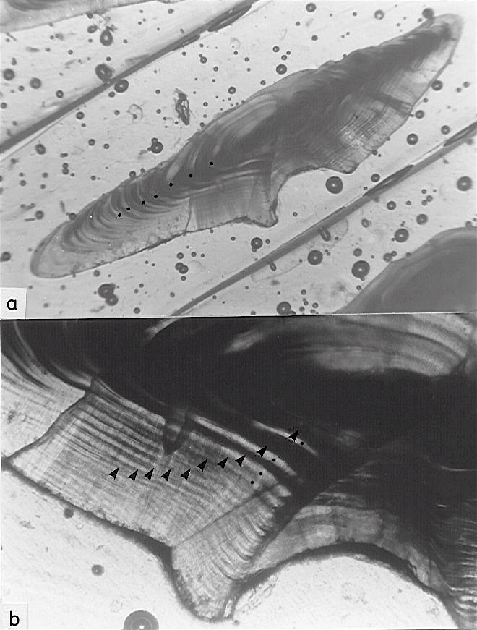
Figure 7: a) S. alutus otolith thin section illuminated with transmitted light. The first several annuli (dots) are indicated.
b) Close up of a). Note how the clarity of the summer zones (arrows) is reduced with age. Annuli (dots) are indicated.

5. Efficiency:
For all phases of the thin sectioning work (preparation, sectioning, ageing) it is estimated that 45-55 structures may be processed per person per day. Different methodologies may differ slightly in efficiency.

Otolith burnt section ageing

1. Equipment required and magnification:
Use a high quality stereomicroscope (i.e. Wild) with at least a range of 6-200x magnification. Cost is approximately $4,000 (Canadian). Good quality optical equipment results in a clearer image and a reduction in eye strain; hence better production and precision.

Good quality microscope lights or double fibre optics are required. Cost is approximately $250-$1000. A highly intense, focused light is necessary in order to clearly differentiate the very narrow annual zones at the outer margin of older, thicker otoliths. Fibre optics are recommended because of the intensity and directness of light produced. As well, no heat is generated providing a more safe environment for close work with hands.

Costs:
Miscellaneous: (cost under $30)
Alcohol burner ($4 - $10).
Ethanol or denatured alcohol (approximately $3/litre).
Forceps to extract otoliths from vials and to hold during burning (approximately $10).
Lighter - Zippo style for safety (approximately $5).
Small paintbrush (50¢).
Modelling clay/plasticine - green or blue ($2).
Shallow watch glass (for holding clay) ($2).
Mineral oil - non-toxic and non-reactive ($1).

2. Processing for ageing:

a. Cleaning the otolith:
Clean the otolith prior to burning by wiping dry with a tissue or first washing in water and then drying. It is necessary to avoid getting any dirt or biological materials onto the section surface when breaking the otolith, as they will burn dark, covering areas of the growth pattern.

b. Breaking/cutting the otolith:
Break the otolith through the nucleus along the dorso-ventral axis. Thinner otoliths may be broken between the fingers and thumbs of both hands or by using forceps and fingers. Thicker otoliths may require deep scoring prior to breaking. The use of a hand saw or an Isomet saw will accomplish this, or the otolith may be broken by pushing it against a sharp corner of a counter top.

The Isomet saw may be used to cut through the entire otolith in order to produce a section with a smooth surface. A large lump of plasticine may be attached to the unmodified chuck of an Isomet saw to hold the otolith in position during the cutting process. It is useful to draw a reference line through the nucleus of the otolith as a guide. The otolith may be held in plasticine attached to a Dennison tag using double sided sticky tape and inserted in a modified chuck (Fig. 5). The plasticine will easily stick to a Dennison tag without the tape if quickly warmed and softened with the fingers prior to mounting the otolith. A more permanent tag may be cut from heavy-duty plastic using a Dennison tag as a model. For some species, a better cut may be produced if the proximal surface (sulcus side) faces outward. The ventral and dorsal tips tend to break off in some cases during the sawing process if the otolith is mounted with the sulcus side facing inward.

Grinding or polishing of the broken surface may improve the surface if it is extremely uneven or irregular. Polishing the section surface is a matter of preference according to individual readers or special circumstances of the otoliths being aged.

c. Burning the otolith:
Using forceps, hold the otolith above the alcohol flame. The higher over the flame the otolith is held, the longer it will take to burn and the more control the reader has in the process. As the section surface begins to burn brown, move the otolith half up, down or sideways to obtain an "even" coloured burn across the entire cross-section surface. In most cases, a medium to dark brown colour is desired. Avoid holding the broken otolith directly in the flame. Better control and evenness (colour) of burn is achieved by distancing the otolith slightly from the flame. The goal is to produce an evenly burnt section that does not over-burn the narrow dorsal and ventral tips.

As the section burns, the annuli colour changes from translucent to reddish to brown to black and then grey (over-burnt). A lighter burn may be required for otoliths of young fish. A longer, "darker" burn is often needed for the thicker otoliths of older fish. The reader should carefully monitor this process by holding the otolith in forceps such that the section is visible to their eye during burning. For some species, progress can be supervised by a brief look under the microscope. Over-burnt or charred section surfaces of otoliths may be removed by abrading the surface if needed, but an attempt to age the otolith should be made prior to grinding.

WARNING: Burnt otoliths can burn skin! Do not touch! Cool the burned otolith approximately 15 seconds.

d. Positioning the otolith under the microscope:
Place the burnt otolith in plasticine/modelling clay of a contrasting colour (i.e., green or blue; avoid yellow, white, red and brown clays). The otolith half should be placed section side "up", perpendicular to the microscope lens. The position and intensity of the light source are factors which can affect annulus recognition. The reader should experiment with the otolith and light angles and/or positions for the best results. Using a small paintbrush, cover the burnt surface of the otolith with oil (non-toxic) to enhance the clarity of the annual zones (Fig. 8 a, b, c). Mineral oil is recommended. If reburning is required, mineral oil does not leave a residue that will burn black and cover up the growth pattern.

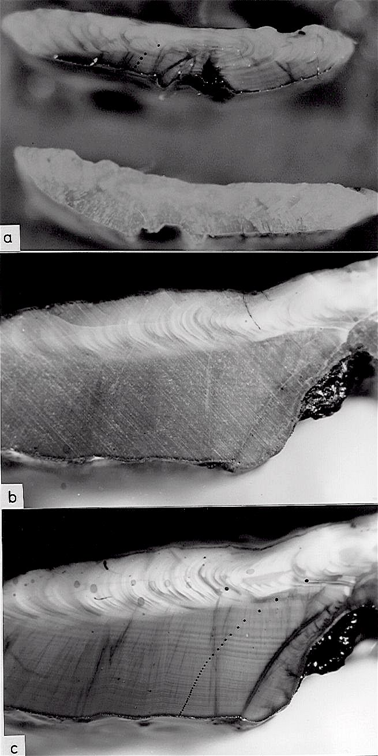
b) Dorsal side of a S. pinniger section before oil was applied.
a) S. flavidus sections of the same otolith with oil applied (top) and dry (bottom).
c) Same section in b) after oil was applied
Figure 8: Examples of burnt otolith sections before and after application of oil and illuminated with reflected light. Note how much clearer the annuli (dots) are once oil was used.

3. Counting axes:
The best areas for ageing are usually found on the dorsal side. Figure 6 outlines the generally preferred counting axes. However, each investigator should verify this for their own species and stock. No axis is equally legible on all rockfish species otoliths.

4. Criteria used in ageing:
The first annulus is usually the first distinct and "complete" dark zone formed "outside" the nucleus (Fig. 9). It may consist of a close grouping of zones which merge near or at the sulcus edge. For the novice reader, there are various ways of using measurement as an aid in locating the first annulus. Experience often overcomes this need. Measurements of the first complete year of growth can be made by using a micrometer or by using increments etched into a probe or forceps. However, measurements should be used with some degree of caution giving leeway for differences between individual fish and the inexactness of the sectioning plane.

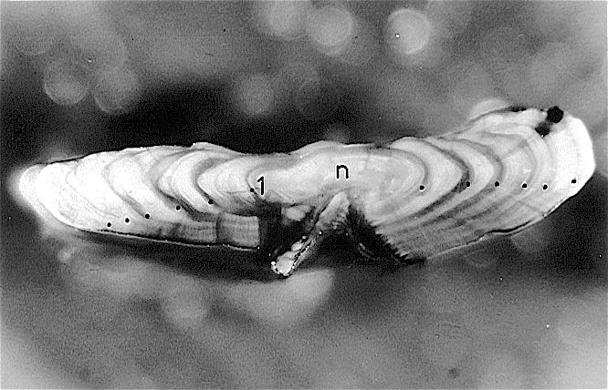
Figure 9: Burnt section of S. flavidus otolith. The first annulus (1) is the first prominent, continuous dark zone formed "outside" the nucleus (n). Annuli (dots) are indicated.

Following identification of the first annulus, each dark, continuous narrow zone that is prominent in the preferred counting areas is counted (Fig. 9, 10 a, b).
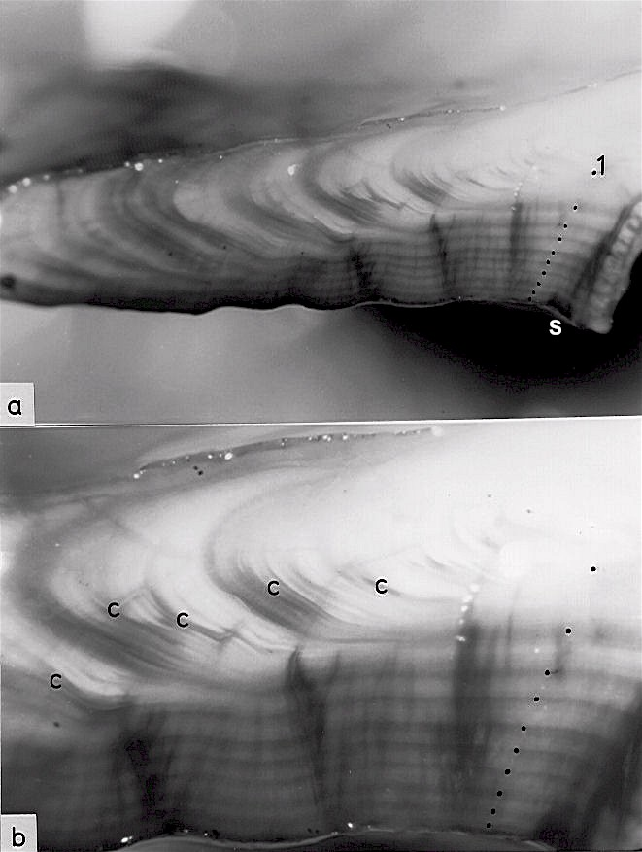
Figure 10: Dorsal side of a burnt section from a S. pinniger otolith.
a) The dark annuli (dots) are most clear in the sulcus (S) area. The first annulus (1) is vague.
b) Close up of a), sulcus view. Note that checks (c) are discontinuous or merge into annuli in the distal area of the section and are not visible in the sulcus area.

When viewing burnt sections, it is helpful to initially scan the distal surface at a low power. This can help to interpret the growth pattern of the earlier years. A gradual increase of objective power enables the reader to derive a more accurate interpretation of the fine growth zones towards the proximal edge.

5. Other procedures:
A freshly broken and burnt otolith is preferred for age determination. Deterioration of the burnt growth pattern clarity can occur over time.

The prominence of different growth zones changes with the amount of burning. The reader should experiment and practice with the range from light to dark, to see what is most suitable for the species and individual otolith being aged (Fig. 11 a, b).

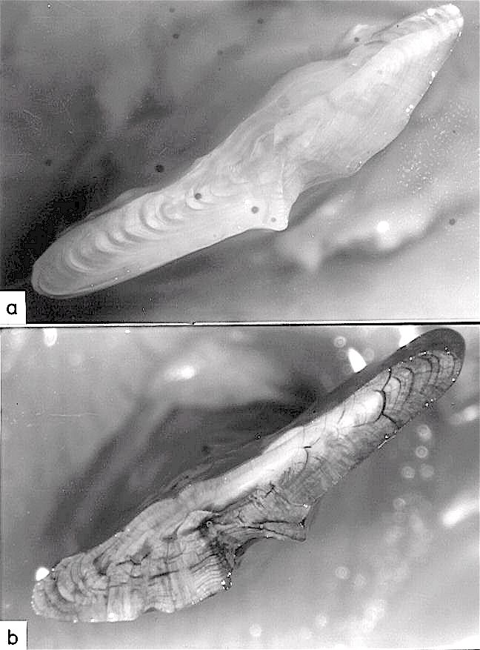
Figure 11: Opposite burnt halves of the same S. alutus otolith. Note the different growth zone characteristics that are emphasized by the different degrees of burning.
a) Very lightly burnt section. b) Over-burnt section.

Age assessment may not be possible for some otoliths that are extremely crystallized. However, for those that are partially affected, a burnt section age is often feasible (Fig. 12 a, b).

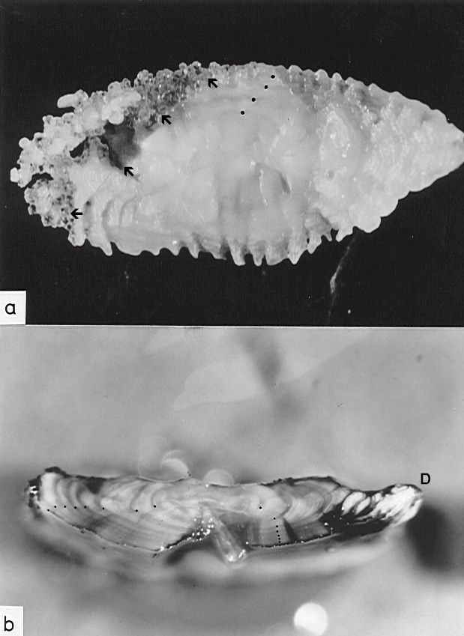
Figure 12: Crystallized S. flavidus otolith.
a) Distal surface showing partial crystallization (arrows). Annuli (dots) are difficult to distinguish.
b) Burnt section of the otolith in a). Note that although crystallization has affected the dorsal tip (D) of the section, it does not interfere with the ability to identify annuli (dots) and estimate age.

6. Efficiency:
An experienced reader, working 5 - 6 hours per day, can optimally age 50 - 100 burnt section readings, depending upon the difficulty of the sample.
August 1984
Revisions & additions April 1997

Sablefish (Anoplopoma fimbria) Ageing Procedures
The sagittal otolith is the recommended structure for ageing sablefish and the burnt section is the preferred method for age determination. The surface is an important aid that may be used without reference to a burnt section for clear, young otoliths. The surface is also a useful age range-finding tool for older specimens.

Sablefish grow very rapidly during the early years of their life and their otoliths can show a rather dramatic slowing in growth after 3-4 years (Fig. 13 a, b). No generalized growth pattern can be applied to all sablefish because many factors appear to affect both the extent and age at which dramatic slowing occurs. Whether the slowing of otolith growth is related to environmental circumstances, sexual maturity or other factors, has not been conclusively demonstrated.
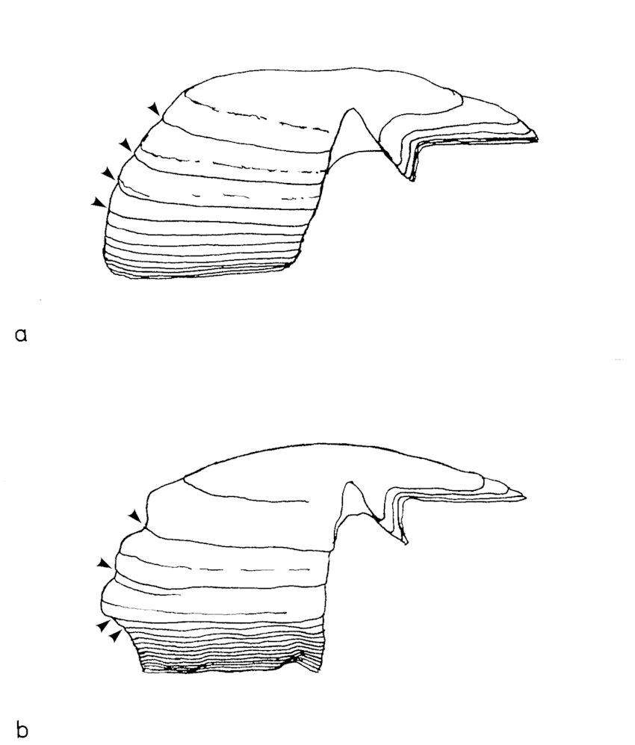
Figure 13: Diagrammatic examples of two common growth patterns seen on sablefish otolith sections. Both show initial rapid growth in the first 3 years. The first four annuli (arrows) are indicated.
a) A growth pattern which shows a fairly gradual slowing of growth.
b) A growth pattern which shows a dramatic reduction of growth after the 3rd year.

Three general otolith section growth patterns are commonly seen in collections:

- Otoliths of fast growing fish which do not show a marked decrease in growth rate at any point (Fig. 14 a).
- Otoliths showing transitional growth zones between the zone of fast growth (typically 3 - 4 years) and the areas of extremely slow growth (Fig. 14 b).
- Otoliths showing a dramatic growth rate decrease after the years of fast growth (Fig. 14 c).
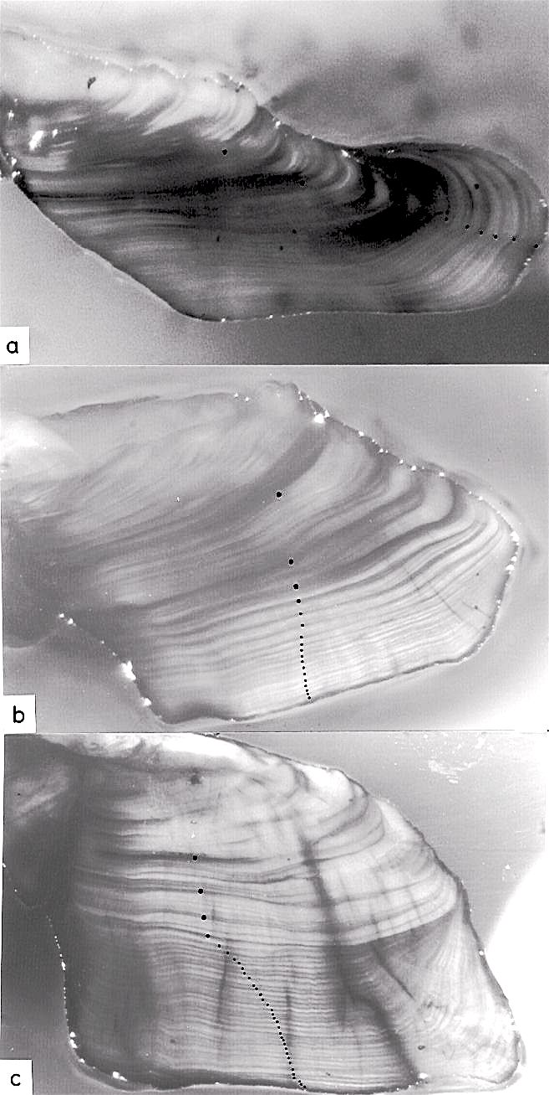
a) A growth pattern showing a continued high growth rate.
b) A growth pattern showing a fairly gradual growth decrease after the 3rd year.
c) A growth pattern showing a fairly abrupt decrease in growth rate after the 4th year.
Figure 14: Ventral side of burnt sections of sablefish otoliths. These are three common types of growth patterns. Annuli (dots) are indicated.
Because of the high variation in sablefish growth, readers are faced with many interpretative options during the age determination process. For this reason, high precision between readers and between agencies is difficult to achieve, and important to discuss and document. Interpretative problems which affect precision may be solved through calibration exchanges.

Interpretative problems include the following:

- The "transition years" are particularly difficult to interpret. They follow the early years of fast growth and precede the zone of slow growth.
- "Incomplete" deposition of annual zones along the proximal edge of the section occurs on the otoliths of some older fish (Fig. 15 a, b). Annual zones appear to form only in the sulcus area and do not extend to the ventral tip. Occasionally, growth zones may accumulate at the ventral tip edge rather than at the sulcus.
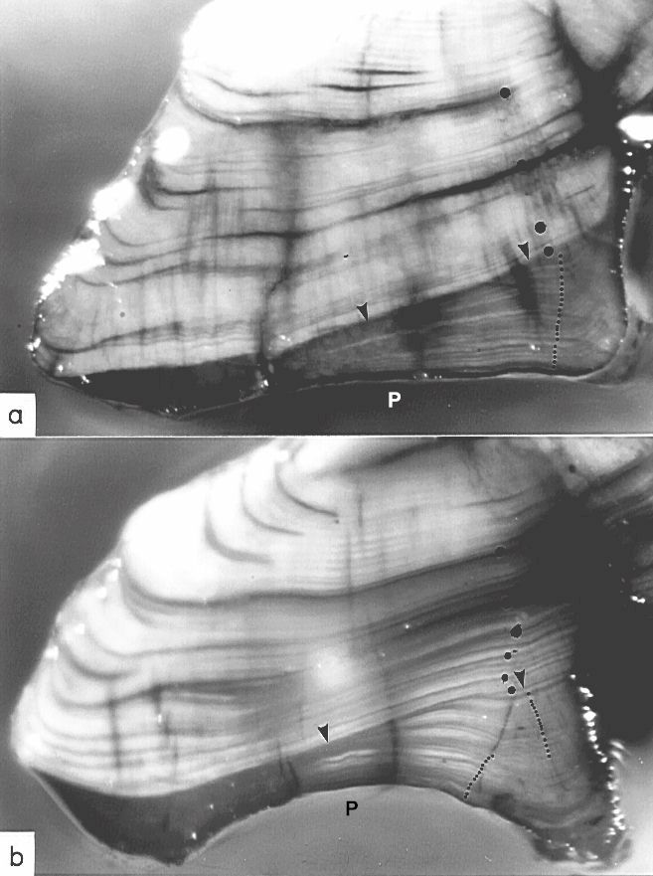
Figure 15: Ventral side of burnt sablefish otolith sections. Note extreme changes in annual growth zone size (arrows) and incomplete deposition of zones along proximal (P) edge. Annuli are indicated (dots).
C.A.R.E. recommends that anyone planning to begin working with sablefish should arrange a preliminary training session with experienced sablefish readers. It is only with hands-on experience and between-agency calibration exercises that precision can be maximized.

The general preparation procedures developed for burnt section ageing of rockfish otoliths (see Rockfish Ageing section) may be applied to sablefish, with the following exceptions:

- Whereas rockfish may be aged using less than 100x magnification, it is recommended that at least 200x be available for use with sablefish otoliths. If possible, acquire higher powered optics (20X eyepieces). Fibre optic illumination must be used.
- As the first year is typically quite large in sablefish, and the otoliths are relatively thin, it is possible to snap the otolith with the fingers, producing a relatively clean fracture plane through the first year. Use of the Isomet saw to produce a usable surface for preparation of a burnt section is not necessary.
- In order to identify the first 3-4 annuli, it is necessary to "tip" the burnt section to trace the prominent grooves containing annuli on the distal surface onto the cross-section surface of the otolith. This procedure enables the reader to avoid identifying prominent checks that are often present in the first few years, as annuli. Reading a burnt section without reference to the surface usually results in over-ageing.
- It is important to try to trace annuli from the ventral tip to the sulcus in order to identify checks that split away from annuli.
- The preferred axis used in ageing sablefish burnt sections includes the area between the ventral tip and the sulcus. Annuli are often more apparent near the sulcus and should be traced from the ventral tip to the sulcus.

April 1997

Lingcod (Ophiodon elongatus) Ageing Procedures

Fin Cross-section Method
Second dorsal fin ray cross sections are currently being used to estimate lingcod ages by the fish ageing labs of the Washington Department of Fish and Wildlife (WDFW), Department of Fisheries and Oceans Canada (CDFO), and the Alaska Department of Fish and Game (ADFG).

1. Equipment/materials required and magnification:
Embedding: fume hood, epoxy (Cyanoacrylate [CA] glue, CA accelerator spray, CA debonder/2-step epoxies, waxed paper (Parafilm), hemostat, gloves
Sectioning: Bronwill/Buehler Isomet or similar saws, glass slides, slide boxes, liquid coverslip (Flotexx/Cytoseal)
Age determination: compound or stereo/dissecting microscope at 30X to 50X, using transmitted light.

2. Preparation for ageing:
In the field, the 4th through 8th fin rays of the second dorsal fin are excised and placed in envelopes and either frozen until preparation in the lab or are dried immediately. Care must be taken to include the base of the fin rays (articulations) so that the first year of growth is not missed.

Although there is variation among the labs in the methodology of preparing the fin ray cross sections for ageing, the process basically includes four steps: drying, hardening, sectioning, and mounting. Tracking of individual fish samples through the collection, preparation, and ageing steps is accomplished by making sure identification numbers are associated with each specimen throughout the process.

a. Drying

Excess fin tissue is most easily removed at the time of sampling. If not, it can be done either after the sample is thawed or dried. The fin is dried in such a way that the final product is flat, with the rays parallel to each other and perpendicular to the baseline of the fin rays. The use of stiff hardware cloth and binder clips can help produce this preferred form. The samples can be air dried (at least overnight or up to several days) or dried in an oven for a shorter time period. Over-heating or extended time in the oven may cause cracks in the bones.

b. Hardening

The purpose of this step is to make sure the sample is rigid enough so that the sections don’t bend, shatter or break while sectioning and to make it easy for mounting the sections. The CDFO and ADFG labs use epoxy to harden the fin sample. The embedding mediums chosen are viscous enough to apply to the fin without dripping and cure clear so that the fin rays can be seen during sectioning. The sample is embedded in epoxy and placed on a Parafilm (a waxed paper) covered board or other similar surface and allowed to dry. The gluing procedure should be done under a fume hood to avoid inhaling toxic fumes.

The WDFW lab uses medium thickness Cyanoacrylate (CA) glue with CA accelerator spray. The fin sample is held at the tip with a hemostat, the CA glue is applied to the total fin sample (except the tip), and the CA accelerator spray is applied to the total fin sample, which hardens immediately. The CA glue will bond human skin to itself or anything else it touches, so a bottle of CA debonder should be available. The CDFO uses different 2-step epoxies that are viscous enough to apply with a Popsicle stick and dry in 24 hours. The epoxy is applied on both sides of the fin at least 40 mm up from the base to provide good support in the saw chuck.

Note* CDFO may also section robust fins (thick sturdy rays) without setting them up in epoxy. The rays must be stiff enough to prevent the fin from bending during sectioning. In this case, no water is used during sectioning.

c. Sectioning

Four to seven sections are cut from each fin using a Bronwill sectioning saw (CDFO) or a Beuhler Isomet sectioning saw (ADFG and WDFW). The Beuhler uses cutting fluid, while the Bronwill saw is modified to use water. The CDFO varies the thickness of the sections slightly (2.6-3.0 mm) for each fin sample, while the other labs cut sections of the same thickness (about 1.5 mm). It is important to mount the fin in the saw chuck so the rays are perpendicular to the plane of the saw blade.

d. Slide Mounting

As the sections are cut, they are laid on the microscope slide in the order they were cut, and in a consistent orientation. They are left to air dry for a few hours or overnight. The sections are then covered with a liquid cover slip (e.g., Flotexx or high viscosity Cytoseal). They should be allowed to dry for at least 24 hours. The mounted sections are then stored in slide boxes.

3. Criteria used in ageing

a. Annual pattern:

Lingcod are fast growing in the first three years of life as reflected in the size of their early annual zones. The following years (4-10) tend to be transition years, when growth slows and annual zone sizes become reduced. The annuli beyond about the 10th year on older lingcod are usually crowded together along the section margin, with “thread-fine” opaque zones between the annuli. Viewing all sections on these older fish usually helps in identifying these later annuli. It should be recognized that the fin method has an upper age limit in terms of accuracy. This occurs sometime in the mid-late teens when annuli become very crowded or stop forming. This can lead to under-ageing.

b. Growth zone criteria:

The annuli are translucent zones that form once a year during the winter months (Fig. 16). They are usually (but not always) prominent and distinct along all growth axes of each fin ray section. Summer growth is an opaque zone that forms during the spring and summer months. Until about age 10, summer growth is usually wider than the annuli. Checks are translucent zones that form within summer growth zones. They often merge with annuli along slower growth axes of fin ray sections or are not present or prominent on all sections. Therefore, it is important to view all the fin ray sections.

The 1st annulus is a crescent shaped translucent zone, of which the interior is mostly translucent on fin sections aged ≥ 2 years (Fig. 16). As sections are sequentially cut further from the fin base changes can be seen in the shape and size of the first year’s growth and the 1st annulus. It becomes “bifurcate” and seems to merge into the 2nd annulus. Checks are most prominent in the 1st few years of growth and confound annuli identification particularly for young/juvenile fish. Early year checks often tend to be distinctive along all axes and may appear in the “middle” of a summer zone or are very closely associated with an annulus (Fig. 17).

Checks within older annual zones may be identified as “double” or “split” annuli. The checks are usually not prominent along all growth axes, with the split visible on the fastest growth axis, and merging with its associated annulus along the slower growth axis (Fig. 18).

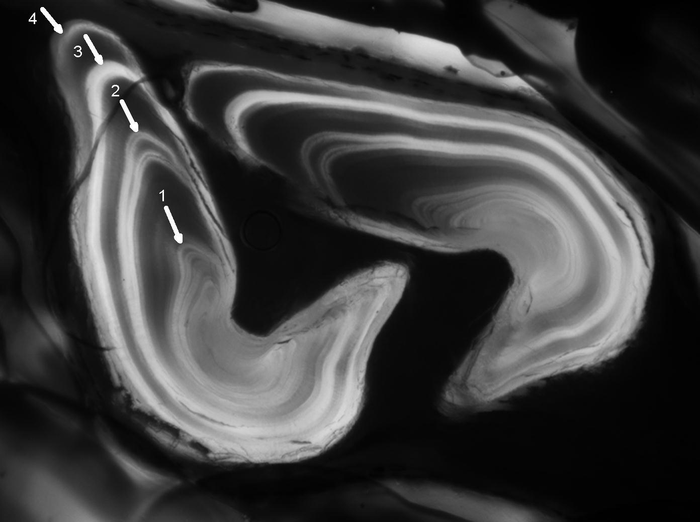 | Figure 16: Lingcod fin ray cross section, age 4. Annuli indicated by arrows.
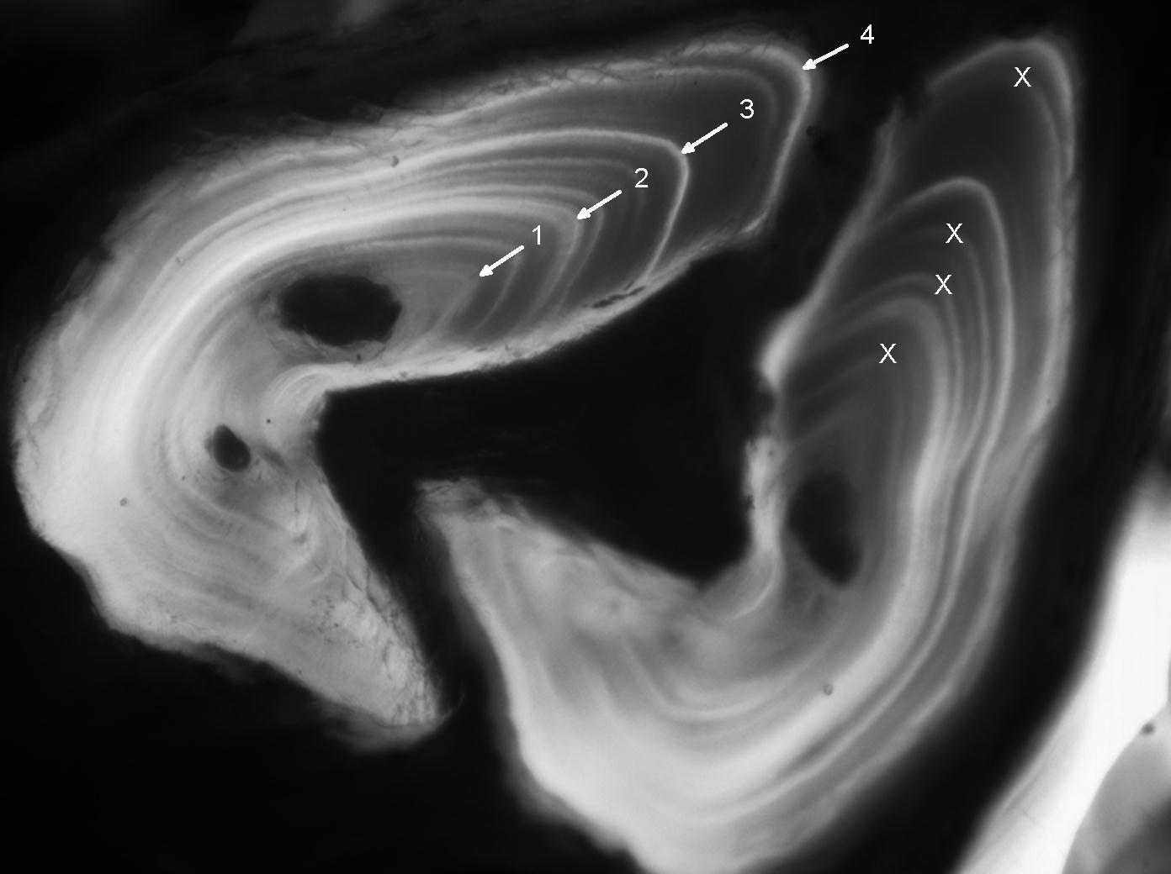 | Figure 17: Lingcod fin ray cross section, age 4. Annuli are indicated by arrows and checks are indicated (X).
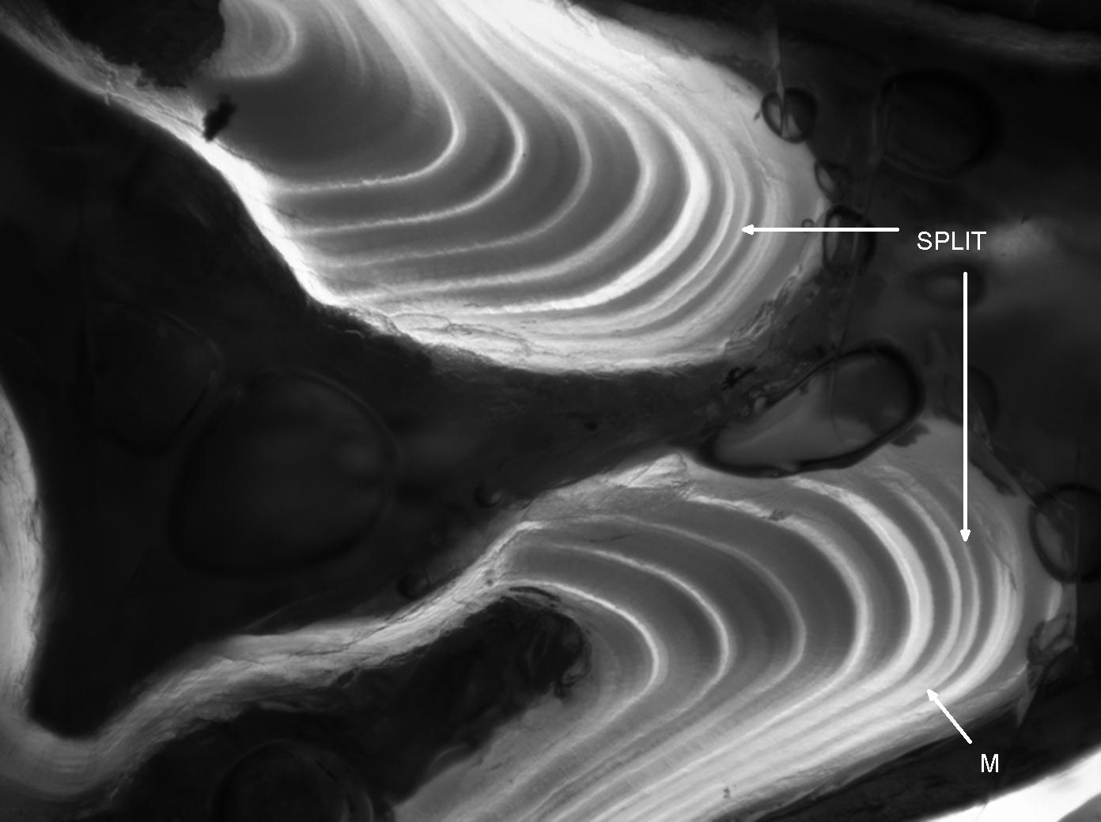 | Figure 18: Figure 18. Lingcod fin ray cross section, illustrating a split annulus. Note where the split merges (M).

c. Measurement criteria:

Measurement criteria for the first few annuli are used to help estimate ages for fins that have checks in their early growth zones. These have been developed by measuring annuli from “known-age” (by length) juvenile fish or fish where these annuli are clearly visible. Comparisons with scales can also help to identify the first few annuli on fin ray cross sections from young fish. The CDFO measurement criteria for the 1st and 2nd annuli are 0.42 ± 0.08 mm and 0.70 ± 0.14 mm respectively. Their measurement is the annulus diameter along the fastest growth axis (Fig. 19). The WDFW developed measurement criteria for the first three annuli: 0.34 mm, 0.66 mm, and 0.92 mm. The WDFW measurement is a radial measurement from the fin ray “center”, along the fastest growth axis (Fig. 19). Measurement criteria were and must be developed from the first few sections cut nearest the fin base as a standard, and are applied only to those sections during age estimation. All measurement values are means. Measurements are converted to eyepiece units, according to the magnification used. Compatibility of these two agencies measuring methods was determined through an inter-lab exchange of structures.

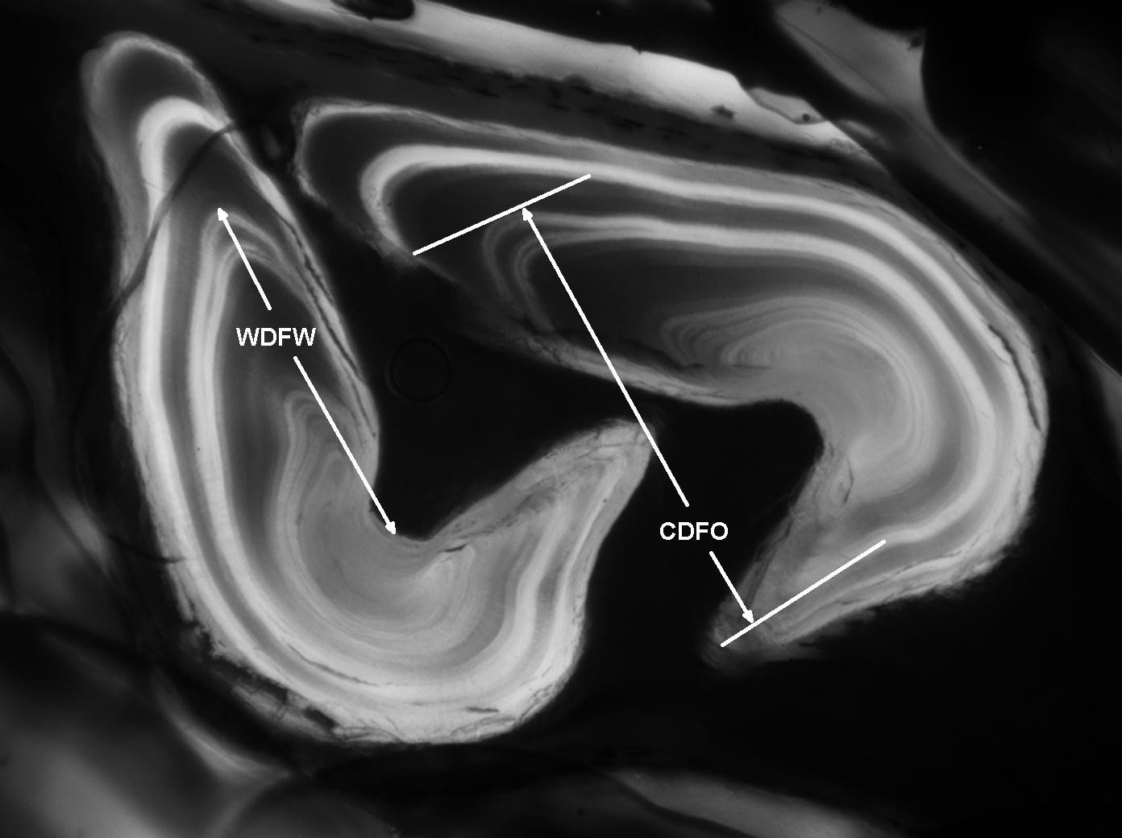 | Figure 19: Figure 19. Lingcod fin ray cross section, illustrating the WDFW and CDFO measurement criteria for the 2nd annulus.

Measurement criteria are also used when sections have resorbed or occluded centers (Fig. 20). This occurs when nerves and blood vessels grow and obscure the central growth pattern of the fin ray. Often, there are one or more sections on a slide where portions of the 1st and 2nd annuli are visible.

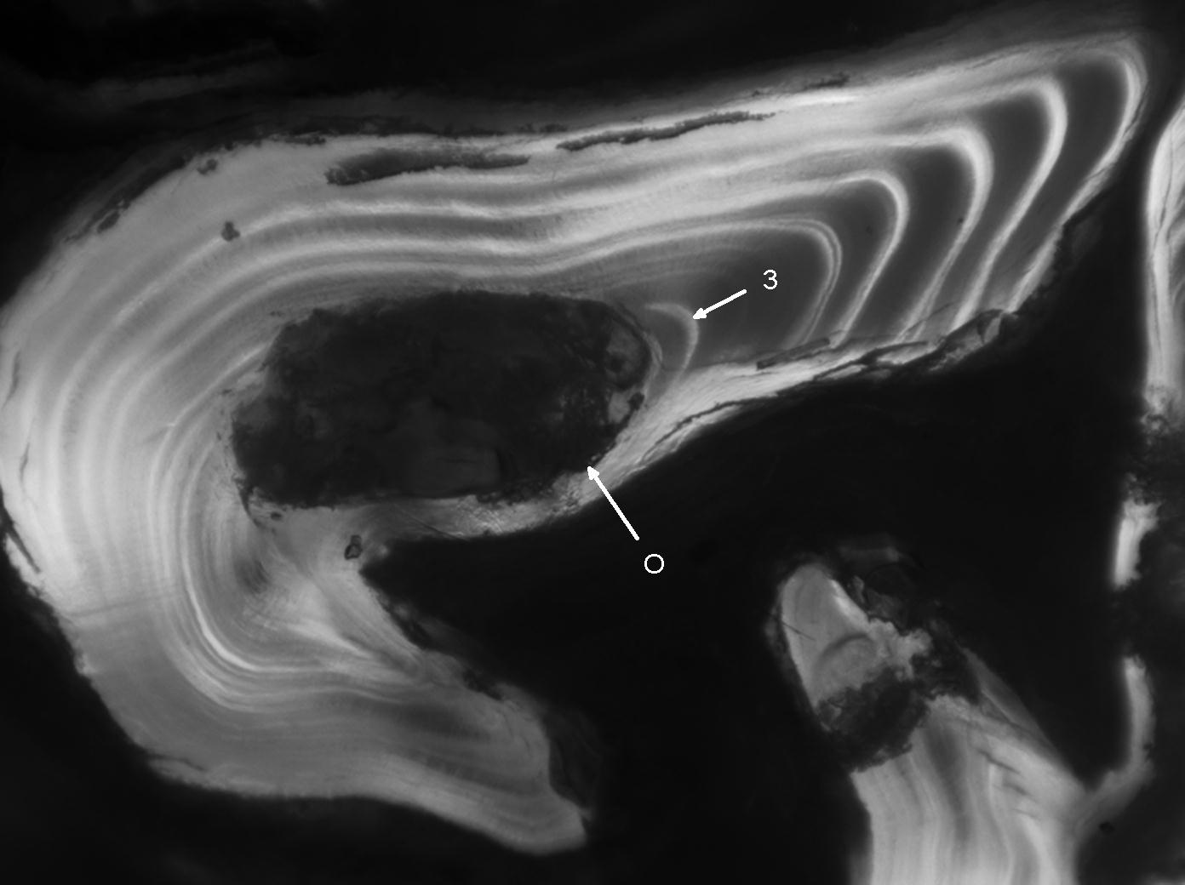 | Figure 20: Lingcod fin ray cross section, illustrating an occlusion (O). The third annulus was determined by measurement.

4. Efficiency
It takes between 2-4 days to trim, epoxy and section 100 fins depending on the field sample quality and size of the fins. The epoxy needs a day to set properly. Two days can be eliminated from this process by sectioning robust fins dry (no epoxy). Approximately 150-200 fish can be aged per day. The rate depends on the clarity of pattern which can be affected by poor sampling practices or technical problems introduced during preparation such as twisted rays and oblique cuts. Speed is also slowed by the presence of prominent checks in the juvenile portion of the pattern or if there is a high proportion of older fish where the centers have been resorbed or annuli are crowded at the section margin and if measurement criteria must be applied to many samples.

Oct 2006

Dover sole (microstomus pacificus) Ageing Procedures

Otolith burnt section ageing
Sagittal otoliths are the recommended structures to determine the age of Dover sole with the burnt section technique of preparation being the preferred ageing method. Flatfish pose unique challenges because the sagittae are not mirror images (Fig. 21) as in other fish.

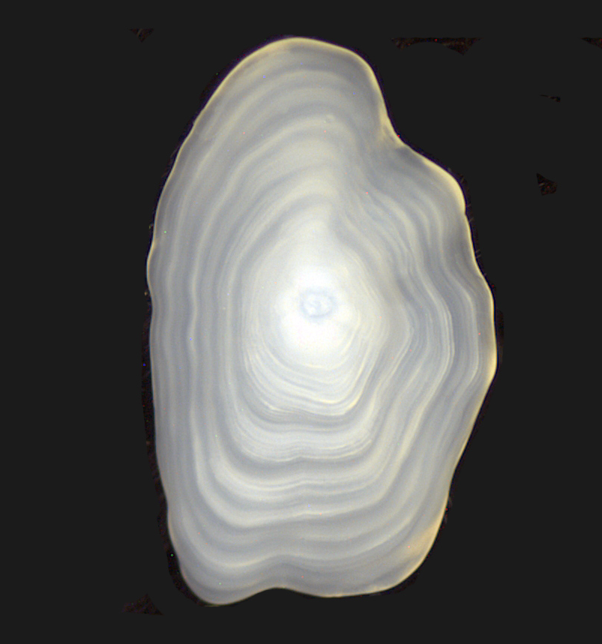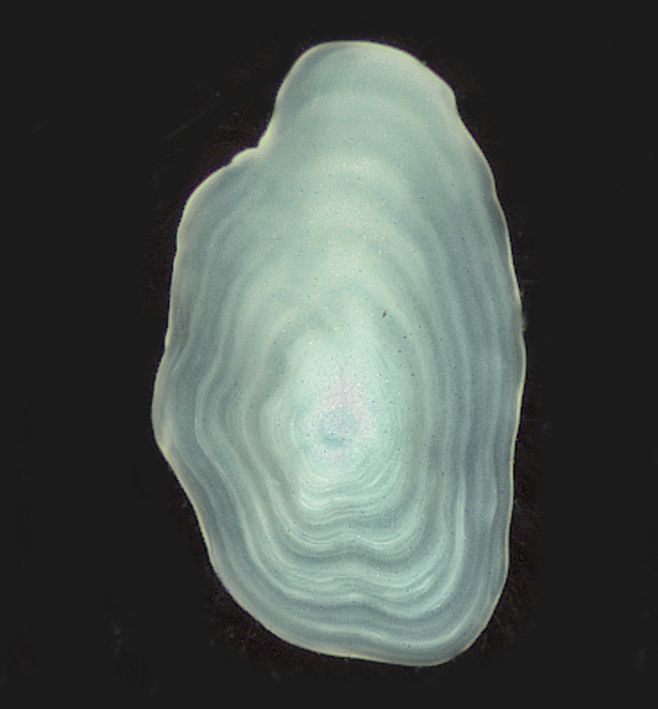
aaa
b

Nucleus

Nucleus

Figure 21. Whole sagittal otoliths from a Dover sole, blind side (a) and eyed side (b). Note the differences with shape and position of the nucleus. The blind side otolith is preferred for ageing.

Equipment, materials and magnification:
Microscope: A high quality optic dissecting scope capable of 6-200X magnification is required. Ergonomic heads and focusing knobs are recommended. Double or triple armed fiber optic lighting are recommended to provide the direct and intense light needed to see small close-spaced annual growth zones.

Materials: forceps, alcohol lamp, modeling clay, paint brush, mineral oil

Preparation for ageing:
General preparation procedures developed for the burnt section method for ageing of rockfish otoliths (see rockfish section) may be applied to Dover sole, with some exceptions.

Because of their small size and the availability of only one preferred otolith from the “blind side” of the fish, special care must be taken when breaking and burning. The part of the forceps depicted in Fig. 22 is useful for producing a clean accurate break through the nucleus. Pill cutters or nail clippers work well with especially thick otoliths. Special care must be taken if it is necessary to use the eyed side (asymmetrical) otolith. Its nucleus is offset posteriorly compared to the blind side otolith. This makes it harder to produce a good clean break through the nucleus.

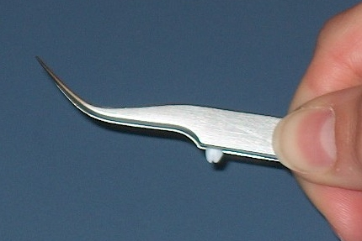
Figure 22. Using the straight edge of the forceps to secure the Dover sole otolith can help achieve a good clean break through the nucleus.

Dover sole otoliths burn quickly due to their small size. Therefore, care must be taken not to over-burn! Keep the flame of the alcohol lamp down very low in order to slowly burn the otolith. Better burning control is achieved by keeping the otolith further away from the flame. Distal and/or nuclear core material may explode out or char away if the otolith is burned too quickly or for too long.

Counting axes:
The preferred reading axis is in the general vicinity of the dark/light boundary (MacLellan 1997). Checks tend to be more prominent towards the dorsal and ventral tips and annuli become overcrowded towards the sulcus. Either the dorsal or ventral side of the otolith may be read, but there is often a discrepancy of one or two years between the sides. If this is the case, it is recommended to assign an age determined from the side that produces the most consistent age.

Criteria used for ageing:
The basic ageing procedures documented for rockfish burnt otolith sections can also be applied to Dover sole with a few differences.

a. Annual pattern:

Lysak (2004) applied marginal increment analysis to fish from the Oregon commercial catch 1990-1992 and determined that annulus formation typically occurs from January through March. This corresponds with translucent growth present on the otolith margin during the winter months. A full year’s opaque growth is most commonly found on the margin from July through December.

The blind side (symmetrical) otolith is preferred for age determination because the annuli are relatively wider spaced and form more distinct, consistent patterns. The eyed side (asymmetrical) otolith is thinner in cross-section, which results in a compressed and convoluted growth pattern that can be more difficult to interpret (Fig. 23). However, if the eyed side otolith is the only one available it is still possible to determine the age. While it is not common, the asymmetrical otolith can have a clearer pattern than the blind side. A note should be made on the data sheet if the final age was determined using the asymmetrical otolith.

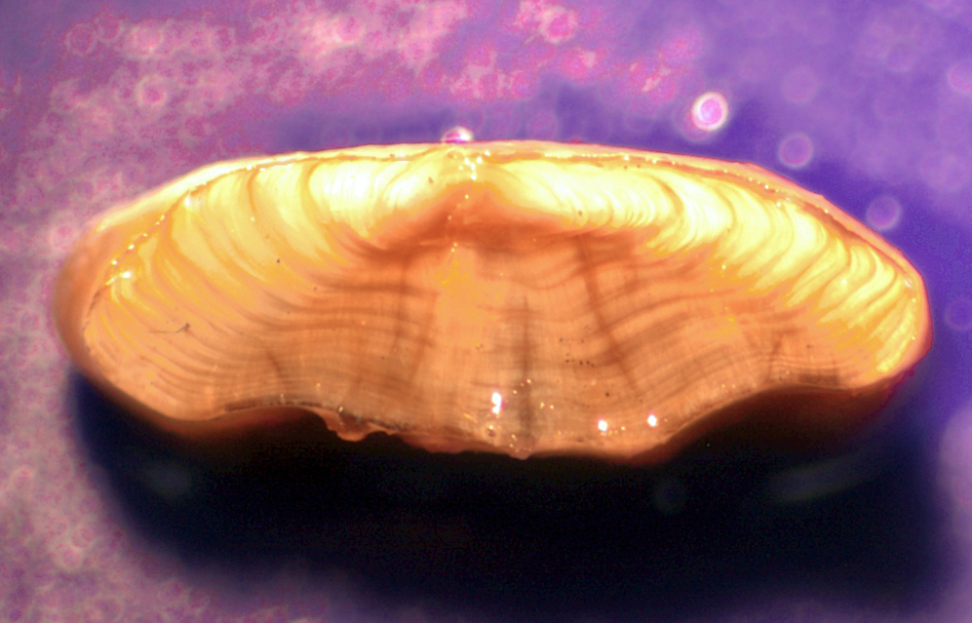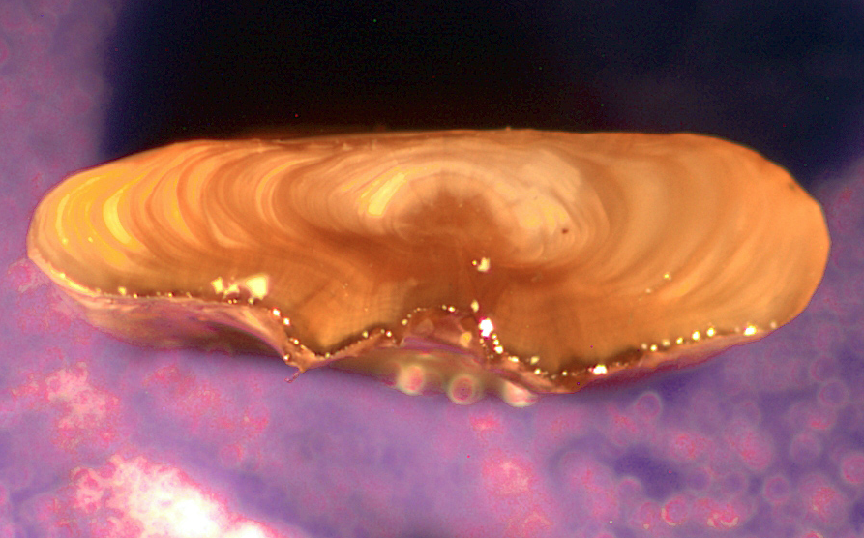
b
a
Figure 23. Broken and burnt cross-sections of Dover sole otoliths, blind side (a) and eyed side (b). Note the difference in thickness. Annuli are much clearer and more uniform on the blind-side otolith. The annuli on the eyed-side otolith are often difficult to interpret.

b. Growth zone criteria:

To identify the first annulus it may be necessary to tip the burnt section to the side to include a partial view of the distal surface. This often improves the distinction between the nucleus and the first two annuli. Ota and Quirollo (1990) suggested adjusting the focus “in and out” to help define the first annulus. The nuclear core will often pop out of the otolith section during burning; if this happens, the distinct core boundary may help determine where the first annulus is located.

Dover sole otoliths generally have three types of shapes based on the approximate age range of the fish. A commonly found “teenage” otolith is shown in Fig. 24 along with a younger and older specimen for comparison. Dover sole otoliths may also show variations in growth patterns, i.e. slow or fast growth, similar to those found in sablefish.

High precision between readers of Dover sole may be difficult to achieve because of several growth pattern interpretive issues. Some of these are commonly found when determining the age of any species, especially within the “transition years” where juvenile growth patterns change to adult patterns. Other interpretive problems are more specific to Dover sole and include:

1. The first annulus can be poorly defined and hard to determine. The more distinct second annulus is usually darker burned and can be mistaken for the first annulus, resulting in under-ageing. Year one should be the first complete visible translucent zone outside of the nucleus (Fig. 25A), even if it is indistinct.
2. Along the proximal edge of the burnt cross-section there may be a “root beer” or brownish-colored area that obscures the actual growth zones (Fig. 25B). If the otolith is slightly broken or chipped on the edge, this may further complicate determining how much translucent and/or opaque growth is really there.

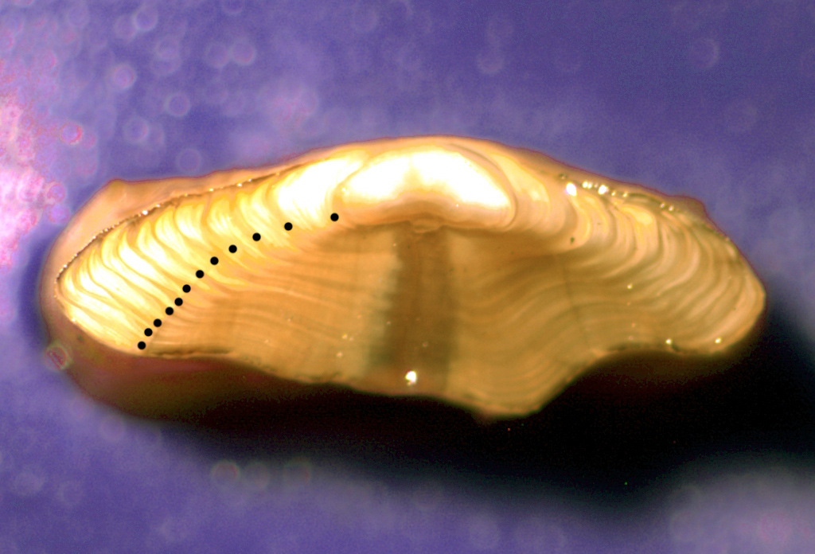  a | a) Teenage Dover sole otolith. The preferred axis to read is in the general vicinity of the dark/light boundary. Either the dorsal or ventral side may be read, although there is often a difference of a year or two between the sides.
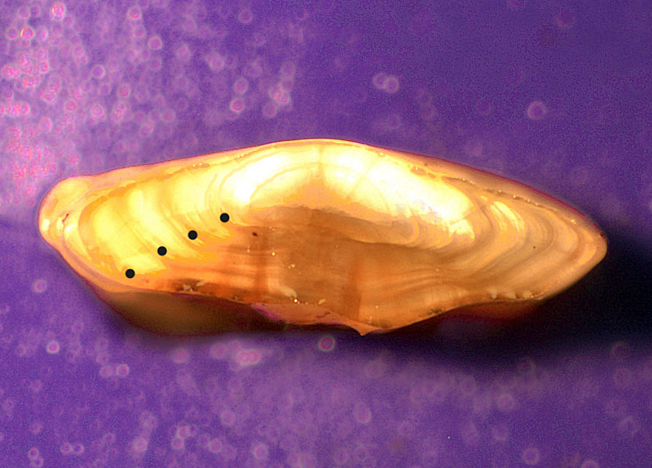  b | b) Young Dover sole otolith. Shape is elongated dorso-ventrally, indicating rapid growth. The first annulus can look like a check and may be difficult to interpret.
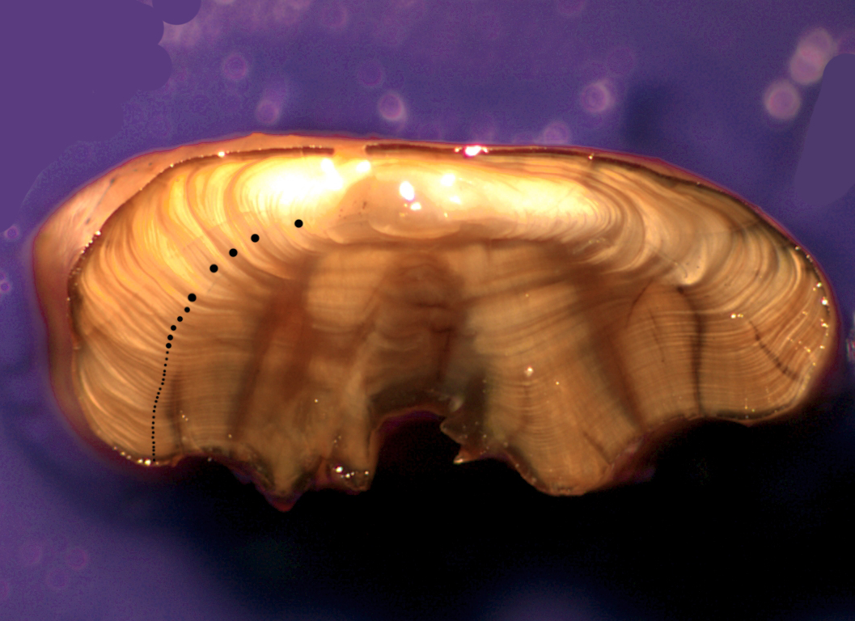  c | c) Older Dover sole otolith. Otolith is relatively thick and square-shaped. The “shoulder” (arrow) indicates a transition from rapid to slow growth, usually at 5 -11 years. Successive annuli are typically compressed and more uniform.
Figure 24. Broken and burnt sections of Dover sole otoliths, showing commonly found growth patterns over a variety of age ranges. Annuli are indicated by dots. Note: Fig. 24 images were taken at different magnifications.

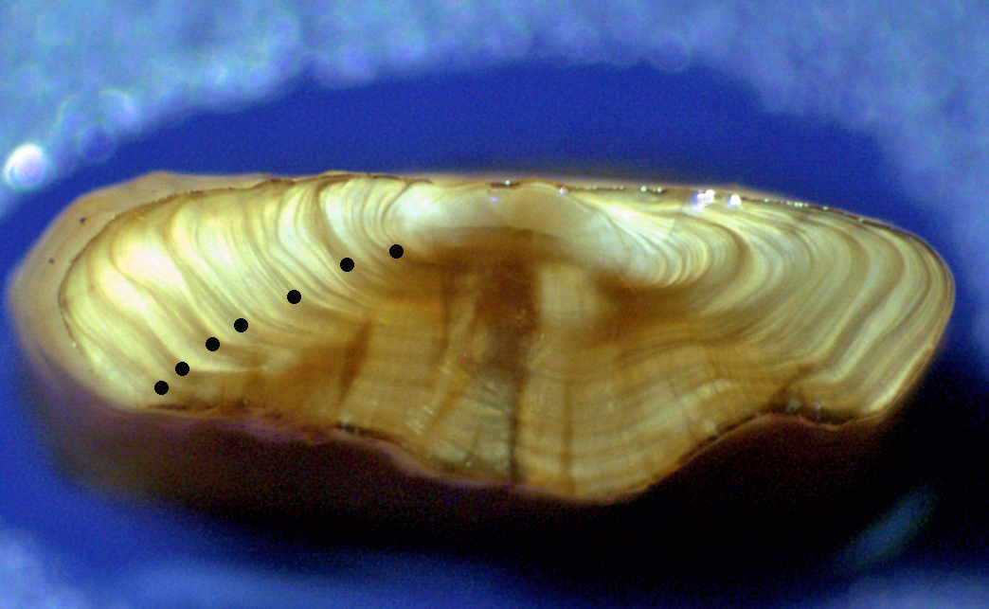
a
First complete year of growth

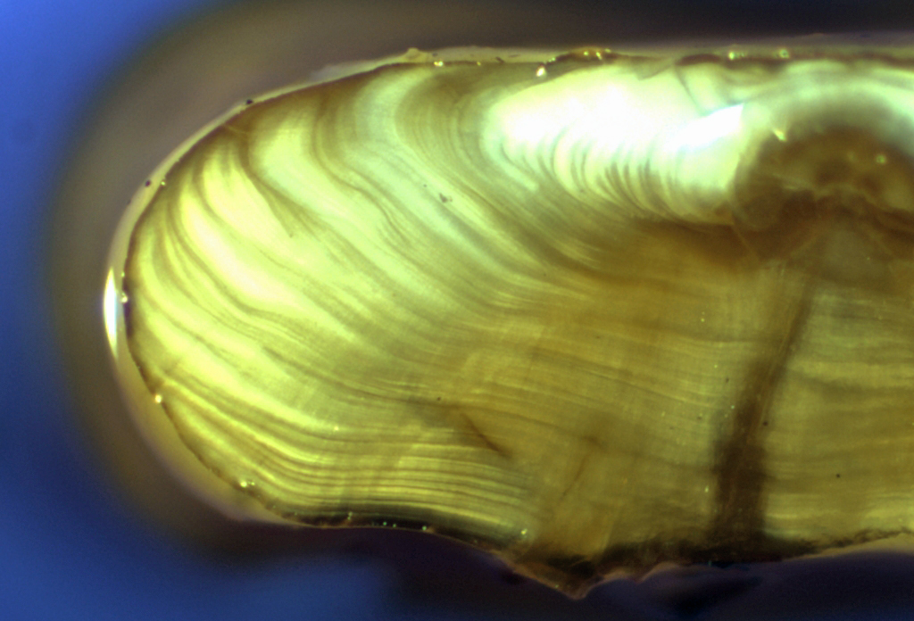
b

Figure 25. Areas of interpretive problems commonly found in Dover sole otoliths. The first annulus is often faint (A) and easy to miss when age reading (annuli are indicated by dots). Along the proximal edge, actual growth can be obscured by a brownish “root beer” colored zone (B).

5. Efficiency:
Approximately 50-60 Dover sole otoliths can be broken, burned and aged per day by NWFSC-PSMFC age readers once a reader has reached production ageing capability. This rate assumes a sample of mixed age classes and moderate difficulty. A particularly old or difficult sample may slow the efficiency rate.

As with any species, C.A.R.E. recommends that anyone planning to begin working with Dover sole should arrange a preliminary training session with someone experienced with Dover sole age determination. Precision between readers should be maintained and interpretive problems can be addressed through calibration exchanges and workshops.

September 2006

This section is dedicated to the memory of Bob Mikus, “Mr. Dover sole.” It would not have been possible without all his knowledge, expertise and kindness.

Glossary

Accuracy - the degree of closeness to the true value (age)

Age class - age assigned in years

Ageing structures - any structure that can be used for age determination; the most common are scales, spines, fin rays, otoliths, vertebrae, operculum, and cleithrum

Annulus - a growth zone that forms once a year; for Pacific Northwest fishes an annulus is identified as the zone that forms during a period of slow or no growth during the winter season

Annual growth zone - all growth on a structure which forms during one year; consisting of a summer zone and a winter zone or "annulus"

Checks - growth zones, denoting a slowing of growth that form within the summer zone; that do not form annually but reflect various environmental or physiological changes

Distal surface or edge - the external surface of the whole otolith or external margin of an otolith cross-section

Edge type - extent of current (year caught) summer growth formed on the margin of an ageing structure

Dark/light boundary - A term used to describe the boundary delineated along a nucleus-to-dorsal tip growth axis on broken and burnt otolith cross-sections. Criteria are applied on this boundary to differentiate checks and annuli where the lighter colored, faster-growth of the distal portion of the section meets the darker burnt, more compacted growth of the proximal side.

Nucleus - term used to describe the origin/larval/embryonic center of growth on otoliths

Proximal surface or edge - the internal surface of the whole otolith or internal margin of an otolith cross-section

Opaque zone (summer zone) - a growth zone that inhibits passage of light and forms part of the annual growth pattern and usually represents a period of faster growth; often referred to as the summer zone; on otoliths it appears dark under transmitted light and white under reflected light

Plus growth - see opaque zone or summer zone, often used to denote unfinished growth from the current (capture) year

Precision - the degree of reproducibility; in age determination it relates to the variability between or within readers

Reflected light - light that is shone onto the surface of an object from above or the side

Sulcus edge or area - the area or margin of an otolith adjacent to the groove on the internal surface

Summer zone (opaque/plus growth) - growth zone that forms during spring and summer; represents a period of faster growth

Transmitted light - light that is passed through an object from beneath.

Translucent zone (hyaline zone, annulus, check) - zone that forms during a period of no or slow growth; on otoliths it appears clear under transmitted light and dark under reflected light

Validation of ageing method - proving a method is accurate, usually by means of a tagging or marking experiment used to create known/partially known-age fish

Winter zone (winter growth, winter rings) - see annulus

Year class - hatch or brood produced in a given year

Note* Some definitions taken from Chilton and Beamish, 1982.

References

Chilton, D.E. and R. J. Beamish. 1982. Age determination methods for fishes studied by the Groundfish Program at the Pacific Biological Station, Nanaimo, Spec. Pub. Fish. Aquat. Sci. No. 60, 102 p.

Beamish R.J. and G.A. McFarlane. 1983. The forgotten requirement for age validation in fisheries biology. Trans. Am. Fish. Soc. 112: 735-743.

Beamish, R. J. and G. A. McFarlane. 1987. Current trends in age determination methodology. In Age and Growth of Fish. Eds. Summerfelt and Hall. pp 15-42.

Christensen, J.M. 1964. Burning of otoliths, a technique for age determination of soles and other fish. J. Cons. Perm. Int. Explor. Mer 29: 73-81.

Lysak, L. 2004. Using marginal increment analysis to validate the periodicity of annulus formation in Dover sole, Microstomus pacificus. Western Groundfish Conference poster presentation, Victoria, BC.

MacLellan, S.E. 1997. How to Age Rockfish (Sebastes) using S. alutus as an Example – The Otolith Burnt Section Technique. Can. Tech. Rep. Fish. Aquat. Sci. 2146: 39p.

Ota, B. and L. Quirollo.1990. Dover sole ageing techniques. California Department of Fish and Game: unpublished proceedings of Dover sole workshop, Eureka, CA.

Power, G. 1978. Fish population structure in arctic lakes. J. Fish. Res. Board Can. 35: 53-59.

Williams, T. and B.C. Bedford. 1974. The use of otoliths for age determination. p.114-123. T.B. Bagenal [ed.] The ageing of fish. Proceedings of an International Symposium. Unwin Brothers Ltd., Surrey, England.

Appendices

List of Tables

Table 1: Agency otolith storage protocols as of 1990. 16

List of Figures

Figure 1: These drawings represent an otolith showing growth stages from one January to the next. Growth timing by month may very somewhat between species, stocks, years or locations. The solid black lines represent the translucent annuli (slow growth) which alternate with wide white zones representing opaque zones (fast growth). The dashed lines designate incomplete opaque growth. The intermediate growth stage from July through December may show a varying amount of new opaque growth on the otolith margin. The 3rd stage presents two possibilities where an annulus may or may not have started to form late in the year following the deposition of lots of opaque growth. Regardless of the type of growth (opaque or translucent) formed at the otolith margin, the age class advances by one year upon January 1st. 7
Figure 2: Distal surface view of a pair of lingcod sagittal otoliths, under reflected light. The top otolith has been cleared while the bottom otolith has not been. Note the distinct annuli (dark zones) of the cleared otolith in comparison to the one that has not been cleared. 13
Figure 3: a) Distal surface of a dry S. alutus otolith, illuminated by reflected light. b) Same otolith as in a) submerged in water. Note that the annuli (dots) are much clearer than in a). 16
Figure 4: Drawing of a rockfish otolith, distal/concave surface up, showing various axes used during age determination. 17
Figure 5: Single saddle chuck and Dennison double-thickness tags used when mounting an otolith on a sectioning card. Note orientation of the otolith on the sectioning card. 20
Figure 6: Drawing of a rockfish otolith cross-section showing areas used for counting and pertinent ageing characteristics (from Chilton and Beamish 1982). 22
Figure 7: a) S. alutus otolith thin section illuminated with transmitted light. The first several annuli (dots) are indicated. b) Close up of a). Note how the clarity of the summer zones (arrows) is reduced with age. Annuli (dots) are indicated. 23
Figure 8: Examples of burnt otolith sections before and after application of oil and illuminated with reflected light. Note how much clearer the annuli (dots) are once oil was used. 26
Figure 9: Burnt section of S. flavidus otolith. The first annulus (1) is the first prominent, continuous dark zone formed "outside" the nucleus (n). Annuli (dots) are indicated. 27
Figure 10: Dorsal side of a burnt section from a S. pinniger otolith. a) The dark annuli (dots) are most clear in the sulcus (S) area. The first annulus (1) is vague. b) Close up of a), sulcus view. Note that checks (c) are discontinuous or merge into annuli in the distal area of the section and are not visible in the sulcus area. 28
Figure 11: Opposite burnt halves of the same S. alutus otolith. Note the different growth zone characteristics that are emphasized by the different degrees of burning. a) Very lightly burnt section. b) Over-burnt section. 29
Figure 12: Crystallized S. flavidus otolith. a) Distal surface showing partial crystallization (arrows). Annuli (dots) are difficult to distinguish. b) Burnt section of the otolith in a). Note that although crystallization has affected the dorsal tip (D) of the section, it does not interfere with the ability to identify annuli (dots) and estimate age. 30
Figure 13: Diagrammatic examples of two common growth patterns seen on sablefish otolith sections. Both show initial rapid growth in the first 3 years. The first four annuli (arrows) are indicated. a) A growth pattern which shows a fairly gradual slowing of growth. b) A growth pattern which shows a dramatic reduction of growth after the 3rd year. 31
Figure 14: Ventral side of burnt sections of sablefish otoliths. These are three common types of growth patterns. Annuli (dots) are indicated. 32
Figure 15: Ventral side of burnt sablefish otolith sections. Note extreme changes in annual growth zone size (arrows) and incomplete deposition of zones along proximal (P) edge. Annuli are indicated (dots). 33
Figure 16: Lingcod fin ray cross section, age 4. Annuli indicated by arrows. 38
Figure 17: Lingcod fin ray cross section, age 4. Annuli are indicated by arrows and checks are indicated (X). 38
Figure 18: Figure 18. Lingcod fin ray cross section, illustrating a split annulus. Note where the split merges (M). 38
Figure 19: Figure 19. Lingcod fin ray cross section, illustrating the WDFW and CDFO measurement criteria for the 2nd annulus. 39
Figure 20: Lingcod fin ray cross section, illustrating an occlusion (O). The third annulus was determined by measurement. 40
Figure 21. Whole sagittal otoliths from a Dover sole, blind side (a) and eyed side (b). Note the differences with shape and position of the nucleus. The blind side otolith is preferred for ageing. 41
Figure 22. Using the straight edge of the forceps to secure the Dover sole otolith can help achieve a good clean break through the nucleus. 42
Figure 23. Broken and burnt cross-sections of Dover sole otoliths, blind side (a) and eyed side (b). Note the difference in thickness. Annuli are much clearer and more uniform on the blind-side otolith. The annuli on the eyed-side otolith are often difficult to interpret. 43
Figure 24. Broken and burnt sections of Dover sole otoliths, showing commonly found growth patterns over a variety of age ranges. Annuli are indicated by dots. Note: Fig. 24 images were taken at different magnifications. 44
Figure 25. Areas of interpretive problems commonly found in Dover sole otoliths. The first annulus is often faint (A) and easy to miss when age reading (annuli are indicated by dots). Along the proximal edge, actual growth can be obscured by a brownish “root beer” colored zone (B). 45

